

**Cairo University**  
**Faculty of Computers and Information**  
**Computer Science Department**

**Graduation project 2015/2016**



**Intelligent To-Do List**

**Dr. Abeer El-Korani**

|  |  |  |
| --- | --- | --- |
| ID | Name | Dept |
| 20120080 | Esraa Salem Ahmed | CS |
| 20120456 | Yasmin Abdel Latif Mohammad | CS |
| 20120196 | Samah Khaled Abd El-Hakem | CS |
| 20120211 | Shimaa Mohammed Hassan | CS |
| 20120455 | Yasmin Ehab Ahmed | CS |

Contents

**list of figures** II

**list of tables** III

**Acknowledgement** V

**Chapter 1: Introduction** 1

**1.1** **Introduction** 1

**1.2** **Motivation** 1

**1.3** **Problem definition** 1

**1.4** **Project Objective (suggested solution)** 3

**1.5** **Suggested Solution** 3

**1.6** **Report Organization (summary of the rest of the report)** 5

**1.7** **Stakeholders** 5

**Chapter 2: Related work** 6

**Chapter 3: System Design** 8

**3.1** **Project specification** 8

**3.1.1** **Functional Requirements** 8

**3.1.2** **Non-Functional Requirements** 13

**3.1.3** **Used Technologies** 15

**3.2** **System Architecture** 16

**3.3** **Backend Class diagram** 18

**3.4** **Backend Subsystem** 19

**3.5** **Frontend Class Diagram** 23

**3.6** **Web Part Class Diagram** 24

**3.7** **Use Case Diagram** 25

**3.8** **Use Case Tables** 26

**3.9** **Sequence Diagrams** 43

**3.10** **System test cases.** 54

**Chapter 4: Screen Shots** 64

**4.1** **ANDROID APP SCREEN SHOTS** 64

**4.2** **WEB SCEENS (ADD OFFER)** 70

**Chapter 5** 71

**5.1** **Conclusion** 71

**5.2** **Future work** 71

**References** 72

# **list of figures**

Figure 1 System Architecture 16

Figure 2 Backend Class Diagram 18

Figure 3 Backend User Subsystem 19

Figure 4 Backend Note Subsystem 20

Figure 5 Backend Ranking & update preferences Subsystem 21

Figure 6 Backend Recommendation Subsystem 22

Figure 7 Frontend Class Diagram 23

Figure 8 Web Part Class Diagram 24

Figure 9 Use Case Diagram 25

Figure 10 - Sequence Diagram - Signup User 43

Figure 11 - Sequence Diagram - Login User 43

Figure 12 - Sequence Diagram – AddOrdinaryNote 44

Figure 13 - Sequence Diagram – AddShoppingNote 44

Figure 14 - Sequence Diagram - AddMeetingNote 45

Figure 15 - Sequence Diagram - AddDeadlineNote 46

Figure 16 - Sequence Diagram - UpdateNote 46

Figure 17 - Sequence Diagram - DeleteNote 47

Figure 18 – Sequence Diagram – Show current and history notes 47

Figure 19 – Sequence Diagram – UpdatePrefFrontEnd 48

Figure 20 – Sequence Diagram – Update preferences backend 48

Figure 21 – Sequence Diagram – getNeareastStores 49

Figure 22 – Sequence Diagram – getOffers 50

Figure 23 - Sequence Diagram - SignupStore 51

Figure 24 - Sequence Diagram - LoginStore 51

Figure 25 - Sequence Diagram - AddOffer 52

Figure 26 - Sequence Diagram - UpdateOffer 52

Figure 27 - Sequence Diagram – DeleteOffer 53

Figure 28 - Sequence Diagram - UpdateStoreProfile 53

# **list of tables**

Table 1 Difference Between our App and Other Apps 7

Table 2 - Use Case Table - Sign up User 26

*Table 3 - Use Case Table - Login User* 26

Table 4 - Use Case Table - Facebook Login User 27

Table 5 - Use Case Table – Add Ordinary Note 28

Table 6 - Use Case Table – Add Shopping Note 28

Table 7 - Use Case Table – Add Meeting Note 29

Table 8 - Use Case Table – Add Deadline Note 30

Table 9 - Use Case Table – Delete Note 31

Table 10 - Use Case Table – Update Note 32

Table 11 - Use Case Table – Update User Profile 33

Table 12 - Use Case Table – Show all current notes 34

Table 13 - Use Case Table – Show history note 34

Table 14 - Use Case Table – Mark a note as finished 35

Table 15 - Use Case Table – Show preferred offers 35

Table 16 - Use Case Table – Show list of nearest stores to user 36

Table 17 - Use Case Table – Update user preferences 37

Table 18 - Use Case Table – Habit detection 38

Table 19 - Use Case Table - Signup Store 39

Table 20 - Use Case Table - Login Store 39

Table 21 - Use Case Table - Update Store Profile 40

Table 22 - Use Case Table - Add Offer 40

Table 23 - Use Case Table - Update Offer 41

Table 24 - Use Case Table - Delete Offer 42

Table 25 - Signup Store Method Inputs 54

Table 26 - Signup Store Method Test Cases 54

Table 27 - Login Store Method Inputs 56

Table 28 - Login Store Method Test Cases 56

Table 29 – Add/Update Offer Method Inputs 56

Table 30 – Add/Update Offer Method Test Cases 57

Table 31 - Signup User Method Inputs 58

Table 32 - Signup User Method Test Cases 58

Table 33 - Login User Method Inputs 60

Table 34 - Login User Method Test Cases 60

Table 35 - Add/Update Ordinary Note Method Inputs 60

Table 36 - Add/Update Ordinary Note Method Test Cases 60

Table 37 - Add Meeting Note Method Inputs 60

Table 38 - Add/Update Meeting Note Method Test Cases 61

Table 39 - Add/Update Deadline Note Method Inputs 62

Table 40 - Add/Update Deadline Note Method Test Cases 62

Table 41 - Add/Update Shopping Note Method Inputs 63

Table 42 - Add/Update Shopping Note Method Test Cases 63

# **Acknowledgement**

Apart from the efforts of us, the success of any project depends largely on the encouragement and guidelines of many others. We take this opportunity to express our gratitude to the people who have been instrumental in the preparation of this project.

We would like to show our greatest appreciation to our Supervisor **Dr.** **Abeer El-Korani**. We can’t say thank you enough for her support and help.

At last, we would like to thank our **Eng. Eman Negm and Eng. Laila Mostafa** for their encouragement and guidance.

# **Chapter 1: Introduction**

## **Introduction**

In our daily life, there are many tasks we have to do and goals we want to achieve in seek of make progress in our lives. Because of we are overwhelmed with tasks, sometimes we feel that we need more than 24 hours to accomplish all our tasks. We may forget some of them even if the context (location and time) is accessible to finish a certain task or wasting time is lower priority tasks all of this take us off track. Another concern is that when you try to create a new habit or to improve yourself this need to do the same task continually without interruption until it turns to a real habit. You need something to remind you with your goals and tasks, help you manage your time and prioritizing your tasks. And this is the goal and importance of our project which will be your To Do list organizer but in intelligent way as we will discuss in coming chapters.

## **Motivation**

Our application will help the users to manage their daily tasks in order to

* Boost their productivity
* Save time
* Organizing and prioritizing their tasks

## **Problem definition**

In this project we use social media and recommendation technologies to provide an intelligent To-Do List application. The application is designed to record the user daily activities and use them, in addition to the user’s Twitter posts, to learn the user preferences. Beyond the normal functionalities of a To-Do list application, like reminding users with their scheduled activities, our application will also try to recommend other activities to the user according to their location and preferences.

**We have three main components in our system:**

* **Notification component:**

We specify 4 types of notes (Ordinary note – Meeting note – Deadline note – Shopping notes)

In this component, there are the main operations of the To-Do list like add, update, delete and show notes. Each type of notes will be handled in different way and all of them will cooperate in the user behavior analysis and know the user preferences and interests which will be used in personalizing activities to the user.

**Notifications are based on four parts**

1. Shopping notes

The user will be notified when there is a near store that sells the products that the user wrote them in the shopping notes.

1. Meeting notes

The user will be notified before the meeting with a specific duration. And user can view the meeting agenda.

1. Deadlines notes

The user will be notified from time to time with progress bar to track her/his achievement at a specific task.

1. Ordinary notes

This type of notes is used to detect the user habits (periodic actions)

* **Recommendation component:**

This component is interested more about understanding the user and giving the user recommendations for offers, places or some actions s/he might be interested in.

In this part we will use social media contents from Facebook or Twitter in addition to the user’s notes in knowing the preferences and its ratio. After analyzing these inputs, we will use a ranking algorithm to output a number that represent the percentage of the user interest of specific category.

According to these ratios we will recommend the user some offers and stores that he might interested in.

* **Offers website**

This website helps stores owners to creates account for their stores and add their offers. They will specify the offers content, offers categories and periods, store location on google maps. We will use this part to recommend the To-Do list app user of some offers that he may interest and match his preferences. These offers will be displayed to the user according to his preferences order.

## **Project Objective (suggested solution)**

* Analyzing and categorizing the user notes to get needed information to understand the user interests and preferences.
* Being able to recommend things to the customer that can please him.
* Help the user to manage his time and perform the tasks that have the greatest impact of his/her progress.

## **Suggested Solution**

Intelligent-To-Do-List android application aims to helps user organize his tasks and responsibilities by making use of the nature language processing operation like text analysis, text categorization to enhance the application and connecting to twitter and facebook to learn the user behavior better. So, user enters his notes. According to the note type system will react in specific way. In shopping note, system will remind user of the product that he wants to buy. with help of store offers component system personalized these offers according to the user’s interests and preferences for example if user is interested in reading and there are offers in some bookstores system will tells user about these offers. In Meeting notes, user will be notified before the meeting time by at least one day before. So user can prepare the meeting agenda. In deadline notes, system will encourage user to accomplish his tasks by displaying a progress bar represents the user progress percentage. In ordinary notes, system will learn more about user behaviors in order to predict user’s periodic actions.

* The system is divided to two parts first “Store offers” as a web application part which helps to process the second part “To-Do-List” as an Android application part.

1. **Website part “Store Offers”:**

this part is responsible for fill the database with shopping offers where the store owner will create an account for his store, enters its location, enters the store

category ex: sports, food, clothes, electronics...etc. and adds offers. The second part will personalize these offers according to the user preferences.

1. **Android part “Intelligent To-Do-List” abstract view:**

The goal of this application is that user can record his notes, which are 4 types (deadline notes, meeting notes, shopping notes, ordinary notes)

This is the core application, consists of two main components.

1. **Notification engine** processes the first 2 type of notes represented in
2. **meeting notification:**

This notification reminds the user before the meeting to remember the appointment and meeting agenda.

1. **deadline notifications:**

This notification reminds the user about his tasks which has a specific deadline. System can track the user’s productivity where user can specify the progress percentage of his task and adjust it till he finishes it.

1. **Recommender engine**
2. **offer recommender engine**

System learns the user preferences by analyzing user’s notes history. According to these preferences system will personalize offers to the user.

1. **habit recommender engine**

System will infer the user habits by analyzing user’s notes history.

## **Report Organization (summary of the rest of the report)**

Later at the rest of the document we are going to talk in:

* Chapter 2 about the closest applications to our application (ITDL) and what makes us different.
* Chapter 3 about the project specifications (Functional and Non-functional requirements), then our application’s class diagrams (Android part and Web part), then use case diagrams and tables, then the sequence diagrams and at the end of this chapter we are going to represent our test cases and the expected output.
* Chapter 4 about our UI at the Android part and the Web part.
* Chapter 5 about our Conclusion and Suggested Future Work.

## **Stakeholders**

We have 2 stakeholders:

* Normal Users → Android application users who add notes
* Store Owner → Offer web page who posting store offers

# **Chapter 2: Related work**

**Google Keep**

**An app that lets you set reminders for what you captured in your mind and reminds you at the right place and right time. You can add notes, images, voice memos to Google keep and share them with your family and friends.** [**https://support.google.com/keep/**](https://support.google.com/keep/)

**Todoist**

**Todoist turns your Android phone into a powerful task manager for personal, professional, and shared projects.**

[**http://todoist.com/android**](http://todoist.com/android)



**Wunderlist**

**Supports timed reminders, recurring to-dos (although its recurring feature is definitely lacking), separate reminders from the due date of the task, notes and additional info associated with your to-dos, shared to-dos with others, multiple categories, and more. You can star important tasks (but that's as close to priority as you'll get)** [**https://www.wunderlist.com/**](https://www.wunderlist.com/)

What makes us different

* **Our application notifies user by messages based on information not only info given by user but also based on information that the application learns from tracking the user behavior from previous notes, tweets and his location.**

Table 1 Difference Between our App and Other Apps

|  |  |  |
| --- | --- | --- |
|  | Intelligent to do list | Other apps |
| Create and edit notes | True | True |
| Set reminders | True | True |
| Share notes | False | True |
| Access tasks everywhere (IOS - Android - Web) | False (future work) | True |
| Detect periodic action and recommend it to user to make him keep track with his goals even if he didn’t enter it | True | False |
| Takes user preferences and refining them using user social media content | True | False |
| Notify user by the nearest stores to do “Shopping notes” | True | False |
| Recommend user by offers according to his preferences as a part of the shopping notes | True | False |
| Notify the user about the deadline notes multiple time before the deadline and make him edit his progress rate in order not to forget his deadlines and to work on them | True | false |

# **Chapter 3: System Design**

## **Project specificatio****n**

### **Functional Requirements**

Abstract view of our system components

the system is divided to two parts first “Store offers” as a web application part which helps to process the second part “To-Do-List” as an Android application part.

The second part has 2 main components Notes components and Recommendation components

So we organize the system functional requirement to 3 parts:

1. **Functional requirements of the Note components:**
2. Sign up

Enter user preferences (after sign up user is asked to enter his initial rating for some defined categories ex: reading, music, health, sports, etc…) these information is required in the recommendation part.

* **Functions that triggered by the user**

1. Login
   1. login by Facebook (to help in extracting his posts to be analyzed further)
2. Logout
3. Update profile
4. Add note (meeting, deadline, shopping, ordinary)
5. Update note (meeting, deadline, shopping, ordinary)

For every type of notes there are different fields inputs ex:in Meeting notes user will enter meeting title, meeting agenda, meeting time. For shopping notes the product that the user wants to buy is required

1. Delete note
2. Note is done

When user finish certain note it is removed from his current notes and saved to the history notes

1. show current notes
2. show history notes (includes notes which marked as done previously)

* **dynamic notification services**

1. fire notification based on Meeting note: when meeting note is entered we set the android system alarm to fire a notification to user to remind him the meeting by 1 day before it and before the transport estimated time in order user not to be late for his meeting when user click on the notification he will be redirected to the meeting information details.
2. Fire notification based on deadline note: when user enters a deadline note system calculates the remaining period from now to the deadline date and fire a periodic notification to remind the user about his deadline when user click on the notification he will be redirected to android activity asks him to edit his progress percentage.
3. There is a synchronization function that runs in the background its role is to synchronize date between the database hosted on the user mobile and the database server on Google App Engine server which we use to host the system web services that runs complex logic. We use it in case user enters some notes and his mobile is not connected to the internet. To make data consistence to be use in further analysis and processing.
4. **Functional requirements of Recommendation engine:**

Most of this part functions are related to the system. Functions are not triggered by the user they are running in the background according to time based threads.

The main role of this part is that to extract user social network content from twitter or Facebook and his recorded notes to be analyzed to refine his preferences weights which user entered them previously as initial weights. That helps in case of cold user who does not have contents on the social media. Or in the beginning of the user install the app on his mobile and does not have notes.

We used a ranking algorithm “Analytical Ranking Processing” which is used to refine the initial ratios of the user preferences weights and choose the most preferred category after sorting the output initial ratios.

1. **The ranking methodology:**

The ranking algorithm is running as a thread in the background of the main application each week this short period is more preferred to analyze user behavior

**Steps for user interests refining:**

1. Extract user content (user notes- twitter or Facebook) for only previous week. We use tweets if user does not log in by Facebook. We store the last date the app runs the algorithm and extract the content for only this period from last update to today
2. Use text categorization tool ‘Alchemy API’ as a Natural Language Processing application to know the category which each text (note – tweet – post) belongs to.

For the project scope we predefine list of categories:

* Health and Fitness
* Art and Entertainment
* Style and Fashion
* Education
* Technology and Computing
* Religion and Spirituality
* Food and Drink
* Reading
* Pets
* Sports
* Movies
* Music

1. we defined a significance weights of each input source ex: if there are 2 statements in sports category and one statement comes from users note and the other comes from user Facebook post we state that the text from user note has more significance rate than the text which comes from Facebook

so from this step we get the count of each category for each input source for example (tables date are dummy data just for illustration):

1. category frequency of the user content is the first input to the ranking algorithm

|  |  |  |  |
| --- | --- | --- | --- |
| Category | User Notes | User FB Posts | User tweets |
| Sports | 3 | 2 | 1 |
| Fashion | 4 | 5 | 0 |
| …… | ….. | ….. | …. |

1. input source significance is the second input for the ranking algorithm

We set the input source significance like this

|  |  |  |  |
| --- | --- | --- | --- |
|  | Notes source | Facebook source | Twitter source |
| significance | 50% | 25% | 25% |

1. user initial weights is the third input for the ranking algorithm

As we mentioned previously user has list of initial weights he enters them after sign up, to solve the cold user problem

|  |  |
| --- | --- |
| Category | Initial weights |
| health and fitness | 40% |
| art and entertainment | 10% |
| style and fashion | 50% |
| education | 30% |
| technology and computing | 80% |
| religion and spirituality | 60% |
| food and drink | 15% |
| Reading | 20% |
| Pets | 0 |
| sports | 0 |
| movies | 40% |
| music | 0% |

Then run the algorithm and the output will be similar to the previous table with the new ratios

As we mentioned this service runs weekly it checks first for the new user content for the previous week before it starts working if it works and gets the updated weights service will fire a notification to the user to inform him that there are updates to your preferences and display it in descending order. And the user has the choice whether to confirm these updates or not. If user accepts to update his preferences, then these rations are updated in the database.

All of the previous work will help in personalizing the offers to the user according his preferences list.

1. **Show preferred offers to the user:**

We use the output of the ranking algorithm represented in updated weights of the user categories and extract the offers if any then notify the user only by the offers that matches his top 3 preferences. When user clicked on the notification a list of suggested offers details is viewed.

This functionality is running in the background of the app every day evening to notify the user of the tomorrows offers if any.

1. **Show nearest stores functionality**

We handle the user shopping notes by notify the user by the nearest stores that sell the product he wants to buy; this is also a function that run in the background. When user clicked on the notification a list nearest stores details are viewed

1. **Show suggested list of actions:**

By analyzing the user history of notes we suggest some notes that are not in his current to do list that he may interest to do or it is a habit for him that will help the user to keep tracks of his goal in indirect way. A list of suggested notes is viewed in form of check boxes Then he marks the check boxes of the notes that he is interested in to be added to his current To-Do list.

1. **Functional requirements of Store Offers part:**

**Website part “Store Offers”:**

this part is responsible for fill the database with shopping offers where the store owner will create an account for his store, enters its location, enters the store category ex: sports, food, clothes, electronics...etc. and adds offers. The second part will personalize these offers according to the user preferences. The main functions as follows:

1. sign up
2. sign in
3. update profile
4. sign out
5. add offer
6. update offer
7. delete offer

**Expected data:**

1. Offer category ex:(Arts and Entertainments, Movies, Music, Food and drinks, Technology, Sports, Health, Religion, Education, Pets and animals, Fashion, Reading).
2. Store name
3. Store address (manager adds the location by google maps)
4. Offer content
5. Duration (start time - end time)

### **Non-Functional Requirements**

* User requirements:
* User should be able to navigate to system without difficulties, system functions name should be self-explained to the user
* System support English language
* User interface requirements:
* The application design should not confuse the user to perform the functionality.
* Colors should be comfortable for the user eye.
* Reusability requirements

The ability to reuse gives the ability to build larger things from smaller parts, and being able to identify commonalities among those parts. In our application:

In implementing our application, we consider the use of SOLID principles of software engineering. We divide the system into components and each class has a single responsibility. We use Model-View-Controller design pattern which helps to extend the system and modify it. We use specific naming convention rules across the team that helps understand the code of each of us.

* Compatibility requirements

The application should be compatible with the android device

* Accessibility requirement:

User can use the application in both case if it is connected to the internet or not. And system will synchronize the data between local mobile database and server as a service in the background.

### **Used Technologies**

In our project we use MVC design pattern. And follow the design principles to allow us modify and extend the functionality easily. The backend logic and database are hosted on Google app engine and we deploy the system functions as web services. And just invoke these web services from the android front end. This methodology was organized and ease dividing tasks across the team.

* Google App Engine:

We use it to host backend of the system functions web services.

Google App Engine (GAE) is a platform as a service (PaaS) cloud computing platform for developing and hosting web applications in Google-managed data centers. App Engine offers automatic scaling for web applications—as the number of requests increases for an application, App Engine automatically allocates more resources for the web application to handle the additional demand. Google App Engine is free up to a certain level of consumed resources. Fees are charged for additional storage

* Alchemy API

This API performs NLP functionalities like sentiment analysis, text similarity, and entity extraction. We used it in the categorized the text to know what it is represent (sports, fashion, art, health, technology…)

There are some other APIs like Uclassify, Dandelion API, Aylien API.

* Facebook API:

Is used in login by Facebook functionality and extracting posts and check ins if the user that we user to analyze and learn the user behavior

* Twitter API

Is used in extracting user tweets to be analyzed in case user not choose to login by Facebook

* Githup

That helps in source code management across the team. We use it to make versions of the code and upload the latest worked version after adding some functionalities.

## **System Architecture**

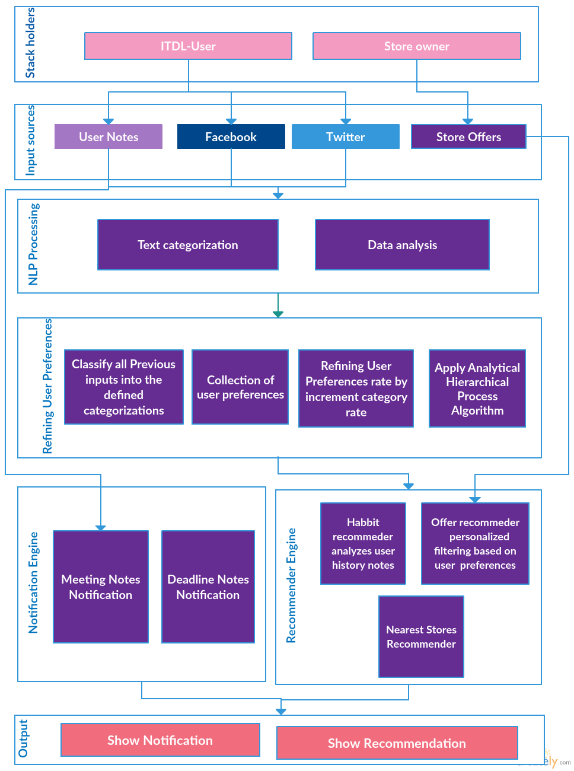

Figure 1 System Architecture

This is the system architecture and workflow of our application. We have 2 main stakeholders Intelligent To-Do List Application (ITDL-User) and the stores owners

We start to collect the application inputs for ITDL-User we get his notes and connect to Facebook and Twitter APIs to extract user tweets, posts and check ins if any.

Next stage is processing these inputs and analyze them by using text categorization and history analysis to help the application learns the user behavior. And refining his preferences to enhance the recommendation engine

Finally, the output of the system in form of notification of the time related notes and a recommendation related to system suggestions based on the information that system learns analyzing user data like suggesting offers, nearest stores and periodic actions.

## **Backend Class diagram**

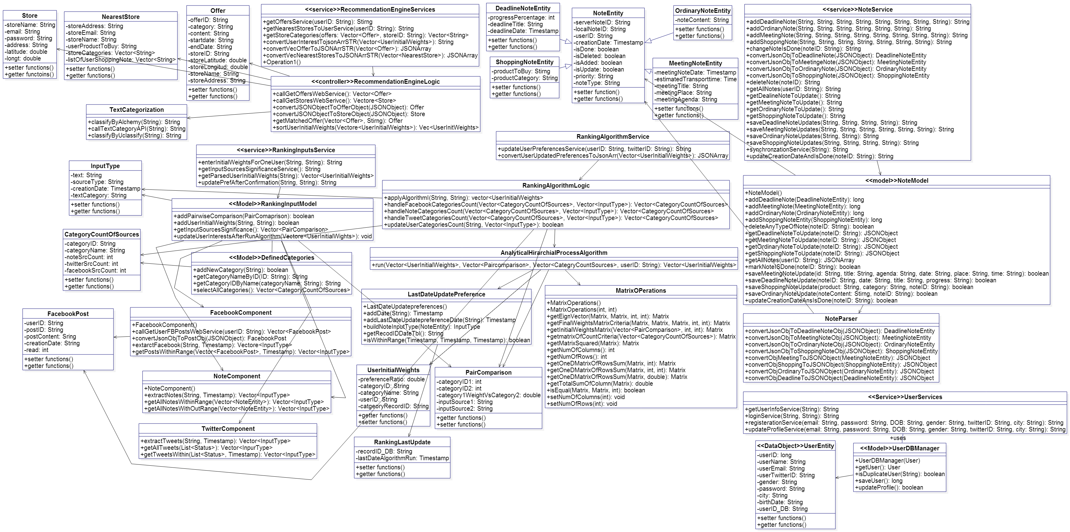

Figure 2 Backend Class Diagram

## **Backend Subsystem**

* + 1. **User Subsystem**

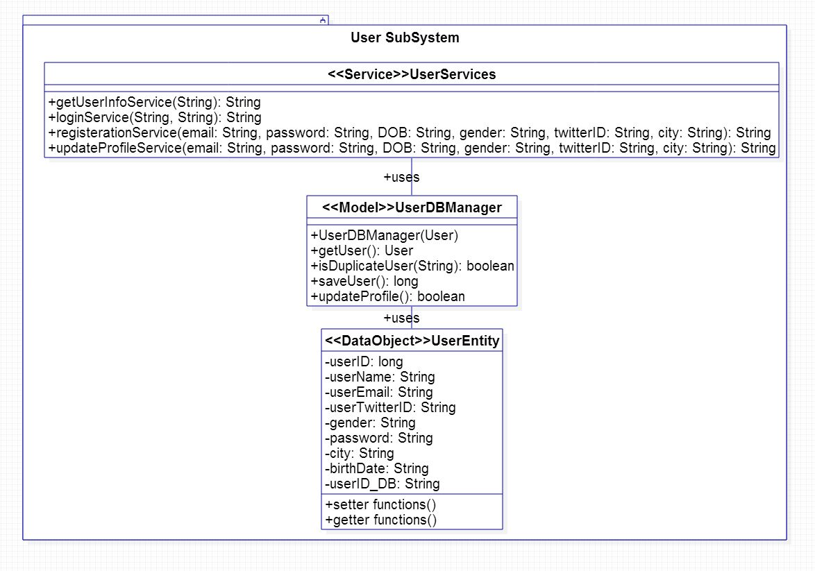

Figure 3 Backend User Subsystem

* + 1. **Note Subsystem**

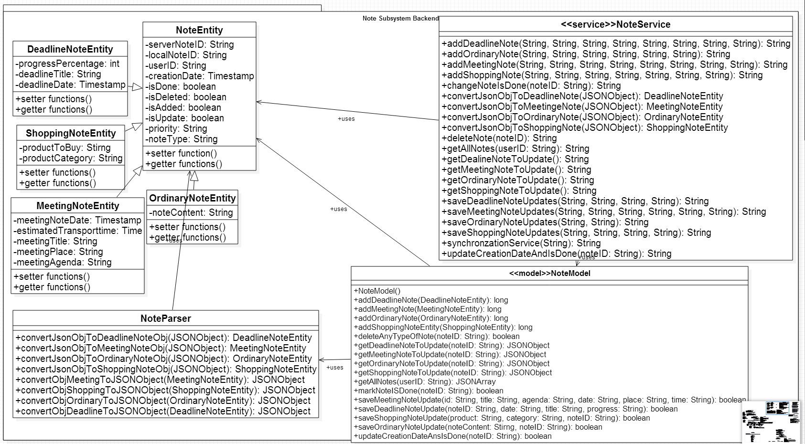

Figure 4 Backend Note Subsystem

* + 1. **Ranking & Update Preferences Subsystem**

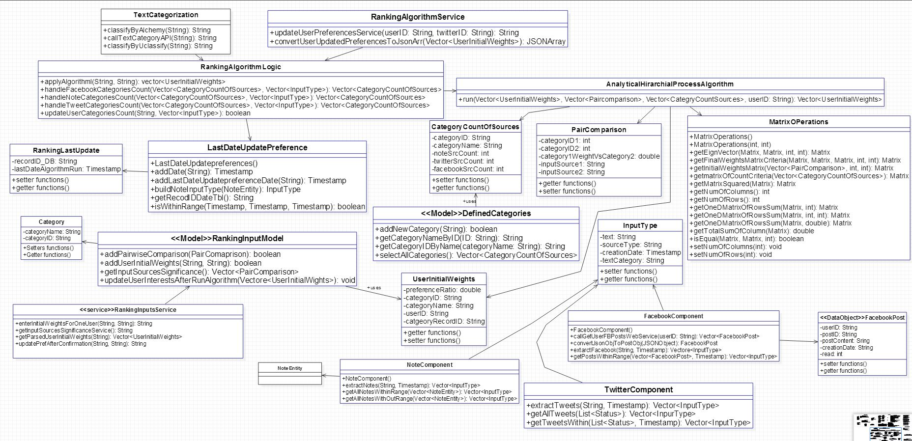

Figure 5 Backend Ranking & update preferences Subsystem

* + 1. **Recommendation Subsystem**

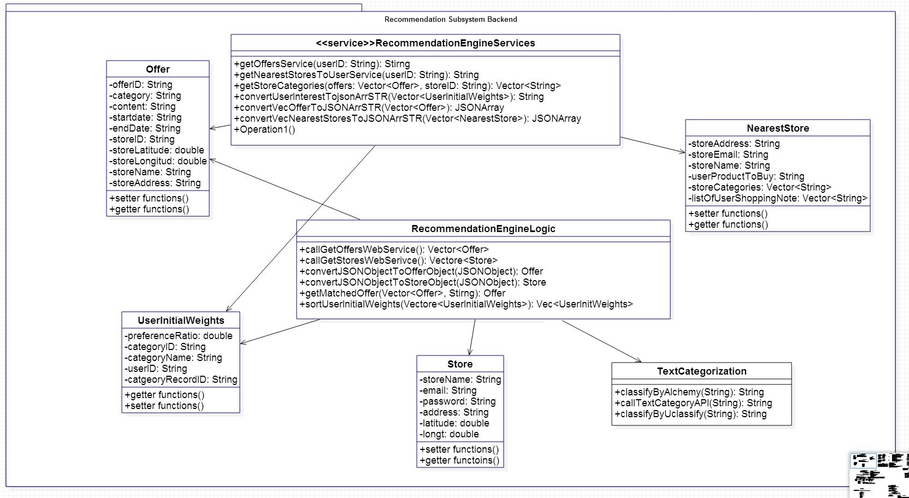

Figure 6 Backend Recommendation Subsystem

## **Frontend Class Diagram**

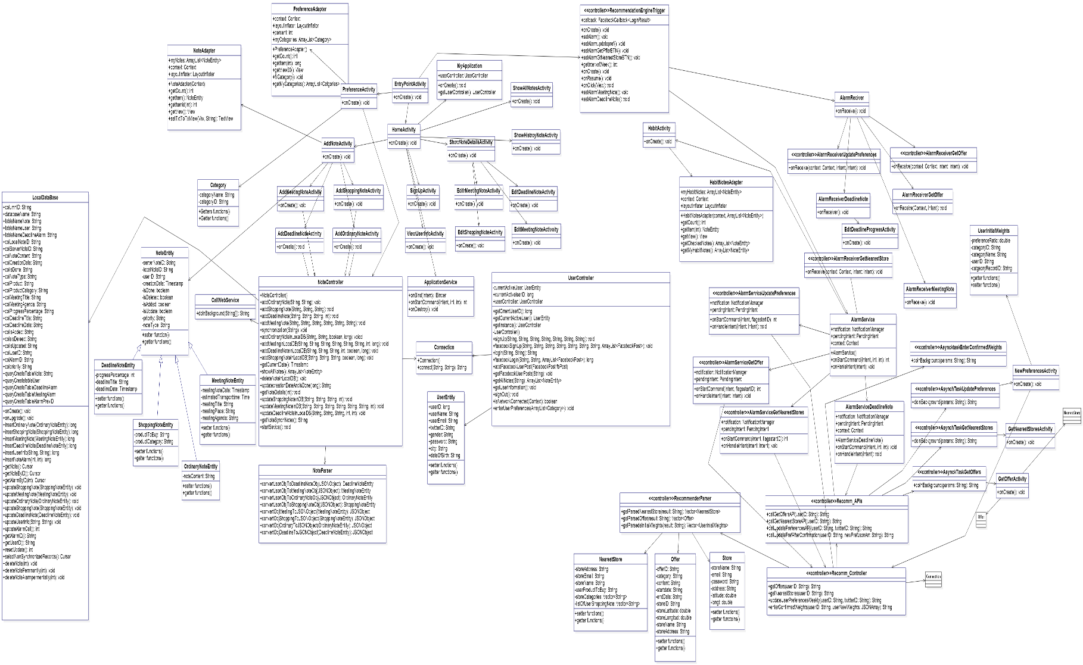

Figure 7 Frontend Class Diagram

## **Web Part Class Diagram**

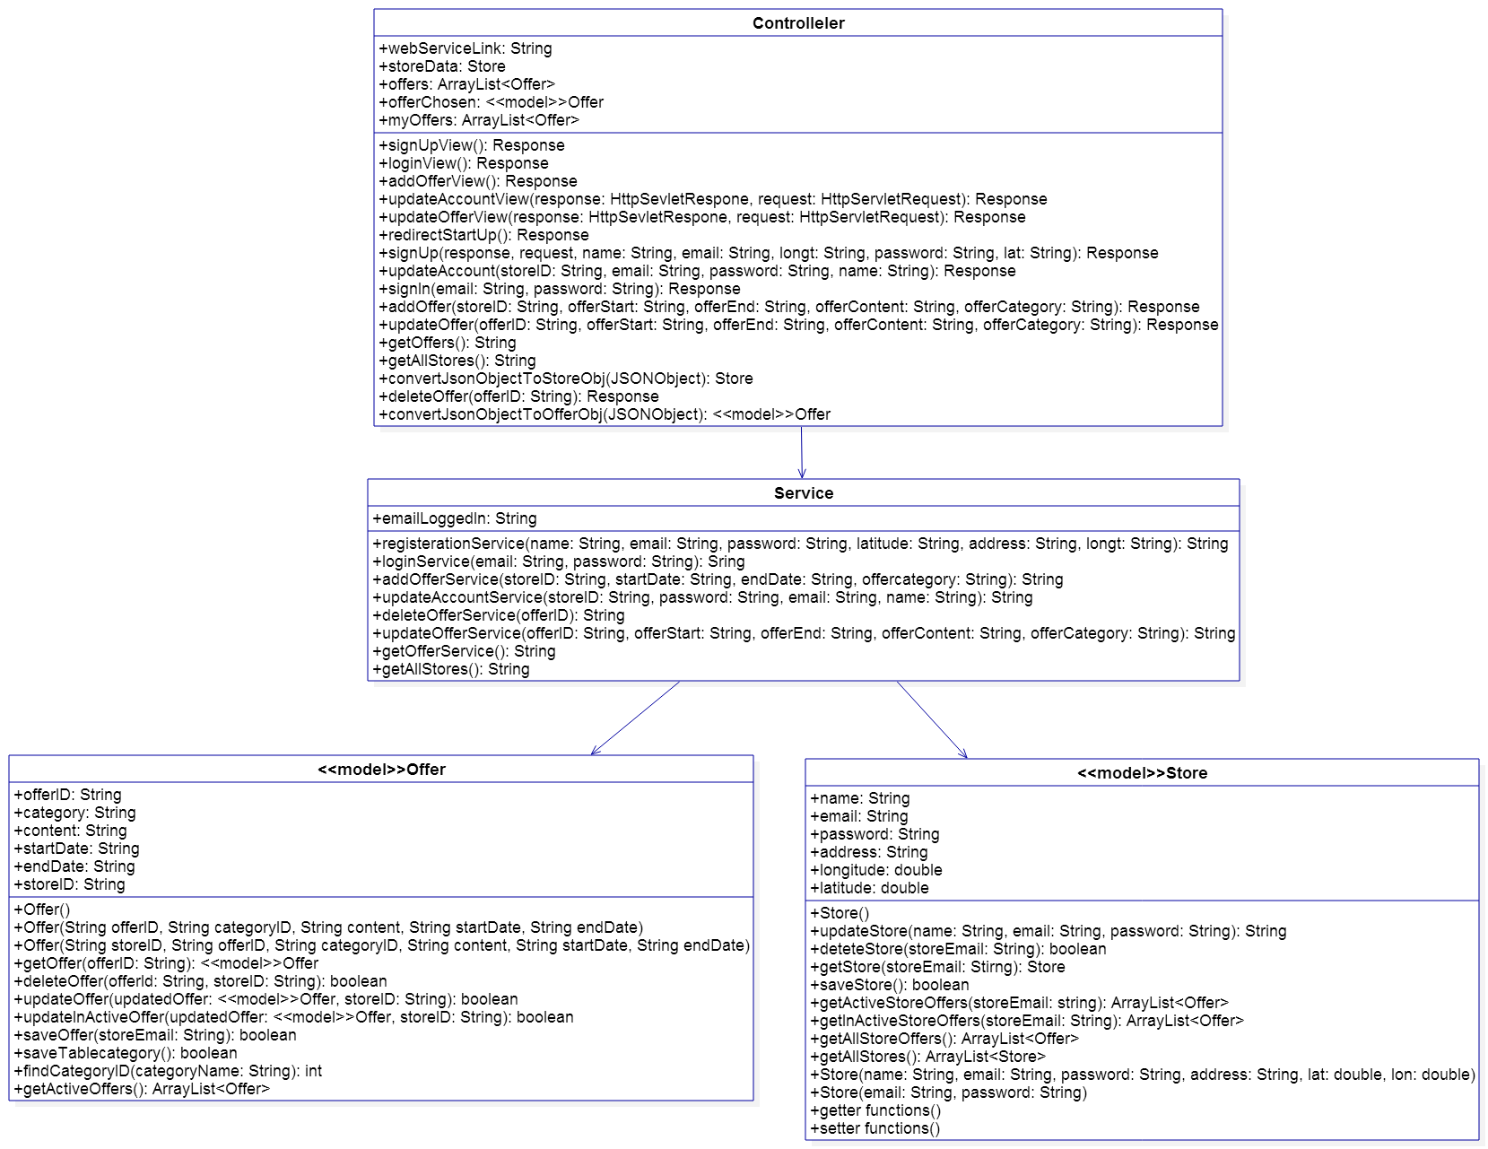

Figure 8 Web Part Class Diagram

## **Use Case Diagram**

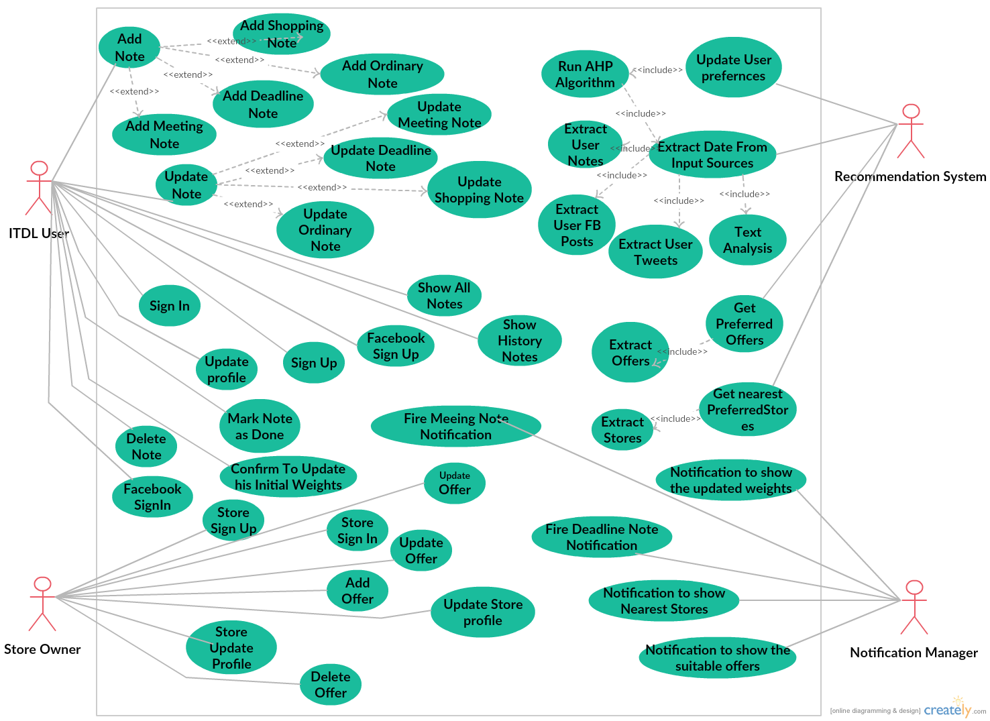

Figure 9 Use Case Diagram

## **Use Case Tables**

* + 1. **Use case tables Notes Part**

Table 2 - Use Case Table - Sign up User

|  |  |  |
| --- | --- | --- |
| UC-1.1 | | **ID** |
| Sign up | | **Title** |
| The user enters his email, name, city and create a new account on the application | | **Description** |
| ITDL User | | **Actor** |
| User should have an email. And there are no duplicate emails. | | **Pre-conditions** |
| Users should enter his preferences list after sign up successfully | | **Post-conditions** |
| **System Action** | **User Action** | **Flow of events** |
|  | 1. User writes his email, name, preferences, location |
| 1. System checks the email duplicates in the database. if the entered email is duplicate. Error message will be displayed. Else user account will be created successfully and redirect to enter initial preferences activity. |  |
|  | 1. Users enters his initial preferences. |
| 1. System creates an account on the application for the user and saves his info and his preferences to the database |  |
| The user enters a wrong formatted email  -The system will ask him to write a right formatted one | | **Exceptions** |

*Table 3 - Use Case Table - Login User*

|  |  |  |
| --- | --- | --- |
| UC-1.2 | | **ID** |
| Log in | | **Title** |
| The user logs in to the application | | **Description** |
| ITDL User | | **Actor** |
| The user already has an account on the application | | **Pre-conditions** |
| User can use the application and create notes | | **Post-conditions** |
| **System Action** | **User Action** | **Flow of events** |
|  | 1-User enters his email and password |
| 2-System checks if the email and password are in the database |  |
|  | 3-User logs in to the application |
| If the user entered a wrong email or wrong password.  -System shows an error message to the user and ask him to enter the right information | | **Exceptions** |
| - | | **Includes** |

Table 4 - Use Case Table - Facebook Login User

|  |  |  |
| --- | --- | --- |
| UC-1.2.1 | | **ID** |
| Facebook Log in | | **Title** |
| The user logs in to the application | | **Description** |
| ITDL User | | **Actor** |
| The user already has a Facebook account and logged in on his device. And there is internet connection | | **Pre-conditions** |
| User can use the application and create notes | | **Post-conditions** |
| **System Action** | **User Action** | **Flow of events** |
|  | 1. User press login by Facebook |
| 1. Facebook API will check the user information if correct. Will redirect him to the application home page. Else error message will be displayed. |  |
|  | 1. User logs in to the application |
| If the user does not setup Facebook application on his device. Or not logged in. and if there is no an internet connection which is required to the Facebook API | | **Exceptions** |
| - | | **Includes** |

Table 5 - Use Case Table – Add Ordinary Note

|  |  |  |
| --- | --- | --- |
| UC-1.3 | | **ID** |
| Add note (Add ordinary note) | | **Title** |
| The user adds an ordinary note in his application | | **Description** |
| ITDL User | | **Actor** |
| The user has the application on his mobile, has an account on it and already logged in | | **Pre-conditions** |
| The note will be saved to the database and the user will be able to update and delete it | | **Post-conditions** |
| **System Action** | **User Action** | **Flow of events** |
|  | 1. the user chooses to add an ordinary note |
|  | 1. the user writes his note and press save |
| 1. if device is not connected to the internet the system will save his note to the local database. And when it connects to the internet the background thread will synchronize the data between local database and the server. |  |
| - | | **Exceptions** |
| - | | **Includes** |

Table 6 - Use Case Table – Add Shopping Note

|  |  |  |
| --- | --- | --- |
| UC-1.4 | | **ID** |
| Add note (Add shopping note) | | **Title** |
| The user can add a shopping note that will help him to remember the things he wants to buy | | **Description** |
| ITDL User | | **Actor** |
| The user has the application on his mobile, has an account on it and already logged in | | **Pre-conditions** |
| The note will be saved to the database and the user will be able to update and delete it | | **Post-conditions** |
| **System Action** | **User Action** | **Flow of events** |
|  | 1. the user chooses to add a shopping note |
|  | 1. User add the information of the note, what he wants to buy |
| 1. if device is not connected to the internet the system will save his note to the local database. And when it connects to the internet the background thread will synchronize the data between local database and the server. |  |
| - | | **Exceptions** |
| - | | **Includes** |

Table 7 - Use Case Table – Add Meeting Note

|  |  |  |
| --- | --- | --- |
| UC-1.5 | | **ID** |
| Add note (Add meeting note) | | **Title** |
| The user can add a meeting note that will help him to remember the meeting and its time | | **Description** |
| ITDL User | | **Actor** |
| The user has the application on his mobile, has an account on it and already logged in. and meeting date is after the meeting creation date. | | **Pre-conditions** |
| The note will be saved to the database and the user will be able to update and delete it | | **Post-conditions** |
| **System Action** | **User Action** | **Flow of events** |
|  | 1. User choose to add a meeting note |
|  | 1. User add the information of the note, place/time/the person he’s going to meet and the topic of the meeting |
| 1. if device is not connected to the internet the system will save his note to the local database. And when it connects to the internet the background thread will synchronize the data between local database and the server. |  |
| 1. system will set an alarm for the meeting date once note is created. System will fire a notification before the meeting date by one day and before the meeting by the transport estimated time. |  |
| 1. system will add these alarms IDs in alarm table with the note ID in order to update these alarms or delete it when note itself is updated and deleted |  |
| The user enters the meeting time of the note that’s before the current time. System shows an error message and ask the user to set a right time | | **Exceptions** |
| - | | **Includes** |

Table 8 - Use Case Table – Add Deadline Note

|  |  |  |
| --- | --- | --- |
| UC-1.6 | | **ID** |
| Add note (Add deadline note) | | **Title** |
| The user can add a deadline note that will help him to remember the things he wants to accomplish and gives him a notification when the deadline is about to end | | **Description** |
| ITDL User | | **Actor** |
| The user has the application on his mobile, has an account on it and already logged in. and the deadline date is after the note creation date. | | **Pre-conditions** |
| The note will be saved to the database and the user will be able to update and delete it | | **Post-conditions** |
| **System Action** | **User Action** | **Flow of events** |
|  | 1. User choose to add a deadline note |
|  | 1. User add the information of the note, end time/a small description |
| 1. if device is not connected to the internet the system will save his note to the local database. And when it connects to the internet the background thread will synchronize the data between local database and the server. |  |
| 1. System will set an alarm for the deadline date once note is created. System will fire a notification when the deadline is about to come |  |
| 1. System will add these alarms IDs in alarm table with the note ID in order to update these alarms or delete it when note itself is updated and deleted |  |
| The user enters the end time of the note that’s before the current time.  -System shows an error message and ask the user to set a right time | | **Exceptions** |
| - | | **Includes** |

Table 9 - Use Case Table – Delete Note

|  |  |  |
| --- | --- | --- |
| UC-1.7 | | **ID** |
| Delete note | | **Title** |
| The user can delete a note he had already made | | **Description** |
| ITDL User | | **Actor** |
| The user has the application on his mobile, has an account on it and already logged in, and has already made a note on the application | | **Pre-conditions** |
| User can use the rest of the application where he can add note/edit note/ update note/ delete note | | **Post-conditions** |
| **System Action** | **User Action** | **Flow of events** |
|  | 1. User click on the notes tab |
| 1. System retrieve all the notes in the database |  |
|  | 1. The user choose the note he wants to delete and press the delete button |
| 1. the system will mark a flag isDeleted to 1 instead of 0 that will help in the synchronization function which will selects the deleted notes from local DB then delete them from the server in case of internet connection is available then delete it from the local DB permanently. |  |
| - | | **Exceptions** |
| - | | **Includes** |

Table 10 - Use Case Table – Update Note

|  |  |  |
| --- | --- | --- |
| UC-1.8 | | **ID** |
| Update note | | **Title** |
| The user can update a note he had already made | | **Description** |
| ITDL User | | **Actor** |
| The user has the application on his mobile, has an account on it and already logged in, and has already made a note on the application | | **Pre-conditions** |
| User can use the rest of the application where he can add note/edit note/ update note/ delete note | | **Post-conditions** |
| **System Action** | **User Action** | **Flow of events** |
|  | 1. User click on the notes tab |
| 1. System retrieve all the notes in the database |  |
|  | 1. The user chooses the note he wants to update and press the update button |
| 1. System retrieve the detailed information of the note from the database and show it to the user |  |
|  | 1. User update the information he wants and press the update button |
| 1. System marks the isUpdated flag in local DB to 1 instead of 0 to synchronize it when it is connected to the internet. Else it will update it in both server and local DB. |  |
| - | | **Exceptions** |
| - | | **Includes** |

Table 11 - Use Case Table – Update User Profile

|  |  |  |
| --- | --- | --- |
| UC-1.9 | | **ID** |
| Update profile | | **Title** |
| User will be able to update his profile and changes some information in it | | **Description** |
| ITDL User | | **Actor** |
| User should have an account on the application and already logged in | | **Pre-conditions** |
| User can use the rest of the application where he can add note/edit note/ update note/ delete note | | **Post-conditions** |
| **System Action** | **User Action** | **Flow of events** |
|  | 1. User choose to update his account |
| 1. System retrieve the information of the user from the database and shows it to him |  |
|  | 1. Users may change his email/Username/Password/Preferences |
| 1. System changes the updated information of the user in the database |  |
| The user enters a wrong password  -System won’t confirm the changes the user made to his account | | **Exceptions** |
| - | | **Includes** |

Table 12 - Use Case Table – Show all current notes

|  |  |  |
| --- | --- | --- |
| UC-1.10 | | **ID** |
| Show all current notes | | **Title** |
| User can display all his notes | | **Description** |
| ITDL User | | **Actor** |
| User should have an account on the application and already logged in. and have some notes | | **Pre-conditions** |
| - | | **Post-conditions** |
| **System Action** | **User Action** | **Flow of events** |
|  | 1. User choose to show his current notes |
| 1. System retrieves the notes whose is Done flag is 0 |  |
| There are no notes | | **Exceptions** |
| - | | **Includes** |

Table 13 - Use Case Table – Show history note

|  |  |  |
| --- | --- | --- |
| UC-1.11 | | **ID** |
| Show history notes | | **Title** |
| User can display notes which pasts | | **Description** |
| ITDL User | | **Actor** |
| User should have an account on the application and already logged in. and have some notes | | **Pre-conditions** |
| - | | **Post-conditions** |
| **System Action** | **User Action** | **Flow of events** |
|  | 1. User choose to show his history notes |
| 1. System retrieves the notes whose is Done flag is 1 |  |
| There are no notes | | **Exceptions** |
| - | | **Includes** |

Table 14 - Use Case Table – Mark a note as finished

|  |  |  |
| --- | --- | --- |
| UC-1.12 | | **ID** |
| Mark a note as finished | | **Title** |
| **User mark note as done note** | | **Description** |
| ITDL User | | **Actor** |
| User should have an account on the application and already logged in. And have some notes. | | **Pre-conditions** |
| - | | **Post-conditions** |
| **System Action** | **User Action** | **Flow of events** |
|  | 1. User choose to show his current notes |
| 1. System retrieves the notes whose is Done flag is 1 |  |
|  | 1. user press on Done button |
| 1. system edits isDone flag to 1 instead of 0 in local DB and synchronize it with the server. |  |
| There are no notes | | **Exceptions** |
| - | | **Includes** |

Table 15 - Use Case Table – Show preferred offers

|  |  |  |
| --- | --- | --- |
| UC-1.13 | | **ID** |
| Show preferred offers | | **Title** |
| **System will recommend user some offers according to user’s preferences list** | | **Description** |
| Recommendation Engine | | **Actor** |
| There are some offers and user initial weights. There is an internet connection in order to run this web service | | **Pre-conditions** |
| - | | **Post-conditions** |
| **System Action** | **User Action** | **Flow of events** |
| 1. system extracts some offers from the offers website |  |
| 1. system extracts user list of preferences |  |
| 1. system selects the most suitable offers for certain user according to his preferences list. |  |
| 1. system fires a notification to the user to inform him to see the list of preferred offers. |  |
|  | 1. User clicks on the notification |
| 1. a list of offers details is viewed to the user. |  |
| - | | **Exceptions** |
| - | | **Includes** |

Table 16 - Use Case Table – Show list of nearest stores to user

|  |  |  |
| --- | --- | --- |
| UC-1.14 | | **ID** |
| Show list of nearest stores to user | | **Title** |
| **List of stores is displayed to the user according to his shopping notes list.** | | **Description** |
| Recommendation Engine | | **Actor** |
| User should have an account on the application and already logged in. And have some Shopping notes. There is an internet connection in order to run this web service | | **Pre-conditions** |
| - | | **Post-conditions** |
| **System Action** | **User Action** | **Flow of events** |
| 1. system extracts user shopping notes. |  |
| 1. System extracts stores that have the same categories of the products that user wants to buy. |  |
| 1. system fires a notification to the user to inform him to see the list of some stores that sells some products he may interest in. |  |
|  | 1. User clicks on the notification |
| 1. a list of stores details is viewed to the user. |  |
| - | | **Exceptions** |
| - | | **Includes** |

Table 17 - Use Case Table – Update user preferences

|  |  |  |
| --- | --- | --- |
| UC-1.15 | | **ID** |
| Update user preferences | | **Title** |
| ITDL user enters a lists of initial preferences at the beginning of using the system. ITDL app tries to learn the system behavior. And refine his preferences list. To enhance the recommendation to the user by analyze his note contents and some of his social media content | | **Description** |
| Recommendation Engine | | **Actor** |
| User should have a content from at least one input source notes ,posts or tweets. There is an internet connection in order to run this web service | | **Pre-conditions** |
| Update the user preferences list in the database when user confirms these updates | | **Post-conditions** |
| **System Action** | **User Action** | **Flow of events** |
| 1. system extract user notes, posts and tweets if any for previous week only |  |
| 1. system analyze the user’s data |  |
| 1. system runs the Ranking algorithm |  |
| 1. system fires a notification to the user to inform him that his preferences were updated |  |
|  | 1. User clicks on the notification and choose yes to update his preferences or no for not updating them |
| 1. if user press yes system will update his preferences in the database and save the last date when the algorithm runs else let the previous rates as it is. |  |
| - | | **Exceptions** |
| - | | **Includes** |

Table 18 - Use Case Table – Habit detection

|  |  |  |
| --- | --- | --- |
| UC-1.16 | | **ID** |
| User habits | | **Title** |
| Show list of suggested actions that the user may interest to do them. That by analyzing his notes history | | **Description** |
| Recommendation system | | **Actor** |
| There is an internet connection in order to run this web service. | | **Pre-conditions** |
|  | | **Post-conditions** |
| **System action** | **User action** | **Flow of events** |
| 1. system extracts the notes of the same current day for the last 2 weeks |  |
| 1. system fire notification to user that there is list of suggested actions |  |
|  | 1. user clicks the notification |  |
| 1. system display list of suggested action in form of check boxes |  |  |
|  | 1. user checks the notes that he may to do it |  |
| 1. system adds the checked notes to the current list of notes. And delete the other unchecked notes from the habit table. |  |  |
| - | | **Exceptions** |
| - | | **Includes** |

* + 1. **Use case tables Web Part**

Table 19 - Use Case Table - Signup Store

|  |  |  |
| --- | --- | --- |
| UC-2.1 | | **ID** |
| Sign up | | **Title** |
| Store owner will create a new account for his store | | **Description** |
| Store owner | | **Actor** |
| Store owner should have a store that sells something and have an email for his store | | **Pre-conditions** |
| Store owner will have an account for his store | | **Post-conditions** |
| **System Action** | **User Action** | **Flow of events** |
|  | 1. Store owner writes his email/Store name/Category/Password |
| 1. System saves his information to the database |  |
| Store owner write an email with wrong format  -System asks the owner to enter a right formatted email  Store owner writes an email that already exists in the database for another account.  -System asks the owner to write a new email. | | **Exceptions** |
| - | | **Includes** |

Table 20 - Use Case Table - Login Store

|  |  |  |
| --- | --- | --- |
| UC-2.2 | | **ID** |
| Log in | | **Title** |
| The store owner logs in to the system so he would be able to perform some functions through it | | **Description** |
| Store owner | | **Actor** |
| The store owner has an account on the system and already logged in | | **Pre-conditions** |
| The store owner can add/update/delete an offer | | **Post-conditions** |
| **System Action** | **User Action** | **Flow of events** |
|  | 1. Store owner enters the email and password for the account |
| 1. System checks the email and password and verify them |  |
| Store owner entered a wrong email or password  -System shows an error message and ask the store owner to enter the right information | | **Exceptions** |
| - | | **Includes** |

Table 21 - Use Case Table - Update Store Profile

|  |  |  |
| --- | --- | --- |
| UC-2.3 | | **ID** |
| Update profile | | **Title** |
| The store owner will be able to update his account information | | **Description** |
| Store owner | | **Actor** |
| The store owner already has an account on the system | | **Pre-conditions** |
| The store owner can use the functions of the system | | **Post-conditions** |
| **System Action** | **User Action** | **Flow of events** |
|  | 1. Store owner changes the information of the account |
| 1. System asks the store owner to enter his password in order to accept his changes |  |
|  | 1. Store owner enters his password |
| 1. The system verify the changes and save them to the database |  |
| The store owner enters a wrong password  -System won’t confirm the changes the user made to his account | | **Exceptions** |
| - | | **Includes** |

Table 22 - Use Case Table - Add Offer

|  |  |  |
| --- | --- | --- |
| UC-2.4 | | **ID** |
| Add offer | | **Title** |
| The store owner adds a new offer that exists in his store | | **Description** |
| Store owner | | **Actor** |
| The store owner already has an account on the system and already logged in | | **Pre-conditions** |
| The store owner offer can be promoted to the users by the application according to the information of the offer | | **Post-conditions** |
| **System Action** | **User Action** | **Flow of events** |
|  | 1. Store owner add a new offer and adds the product name/category/price/start date/ end date |
| 1. System adds the offer to the database with all its information |  |
| The store owner adds an offer that’s already exists in the database.  -The system shows an error message that the offer is already exists. | | **Exceptions** |
| - | | **Includes** |

Table 23 - Use Case Table - Update Offer

|  |  |  |
| --- | --- | --- |
| UC-2.5 | | **ID** |
| Update offer | | **Title** |
| The store owner updates an offer that exists in his store and in the offers database on the system | | **Description** |
| Store owner | | **Actor** |
| The store owner already has an account on the system and already logged in and already made an offer that he wants to edit | | **Pre-conditions** |
| The store owner offer can be promoted to the users by the application according to the information of the offer | | **Post-conditions** |
| **System Action** | **User Action** | **Flow of events** |
|  | 1. The store owner chooses the offer he wants to update |
| 1. The system retrieves its information and shows it to the store owner |  |
|  | 1. Store owner changes the information he wants and press the update offer button |
| 1. System saves the new information of the offer to the database and deletes the old one |  |
| - | | **Exceptions** |
| - | | **Includes** |

Table 24 - Use Case Table - Delete Offer

|  |  |  |
| --- | --- | --- |
| UC-2.6 | | **ID** |
| Delete offer | | **Title** |
| The store owner deletes an offer that exists in his store and in the offers database on the system | | **Description** |
| Store owner | | **Actor** |
| The store owner already has an account on the system and already logged in and already made an offer that he wants to delete | | **Pre-conditions** |
| The offer no longer exists in the database of the system | | **Post-conditions** |
| **System Action** | **User Action** | **Flow of events** |
|  | 1. The store owner chooses the offer he wants to delete |
| 1. System deletes the offer from the database |  |
| - | | **Exceptions** |
| - | | **Includes** |

## **Sequence Diagrams**

**Android Part**

**SignupUser**

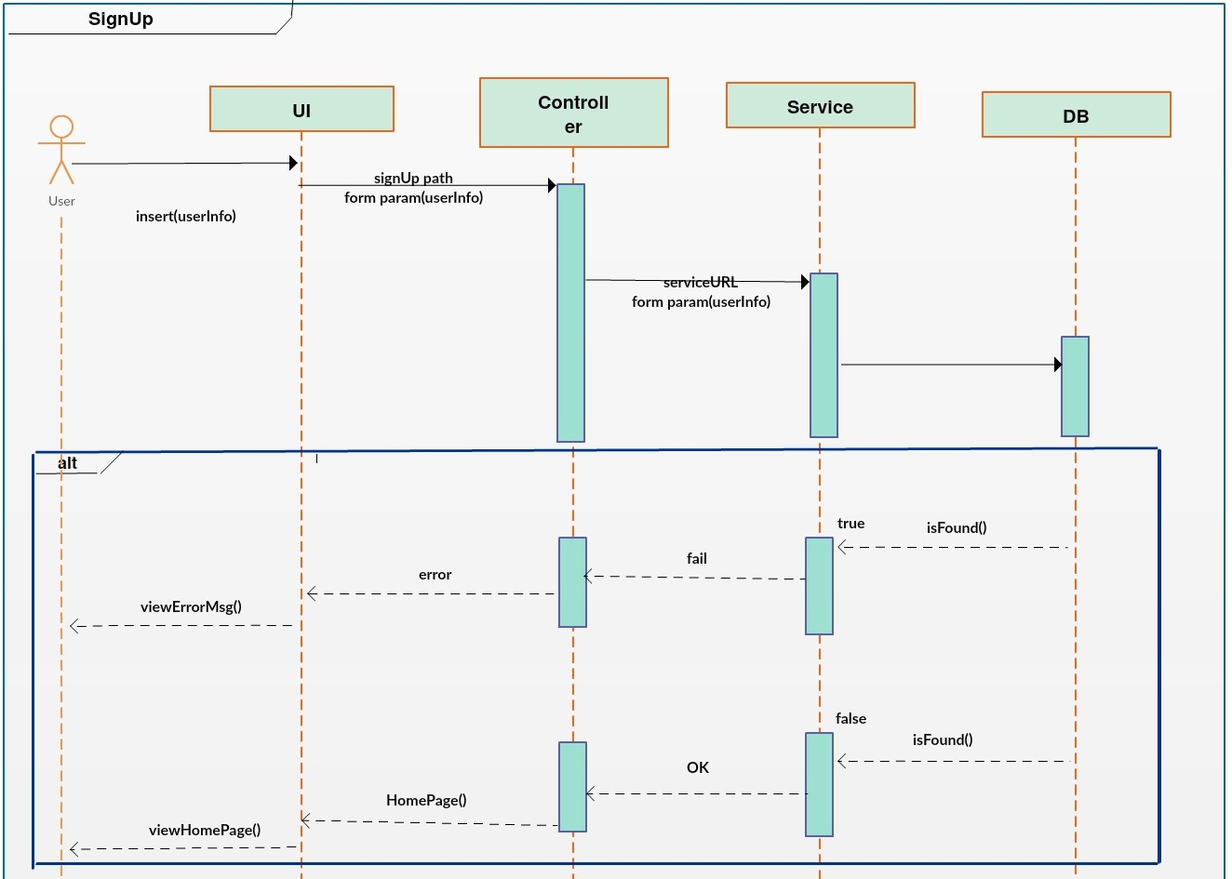

Figure 10 - Sequence Diagram - Signup User

**LoginUser**

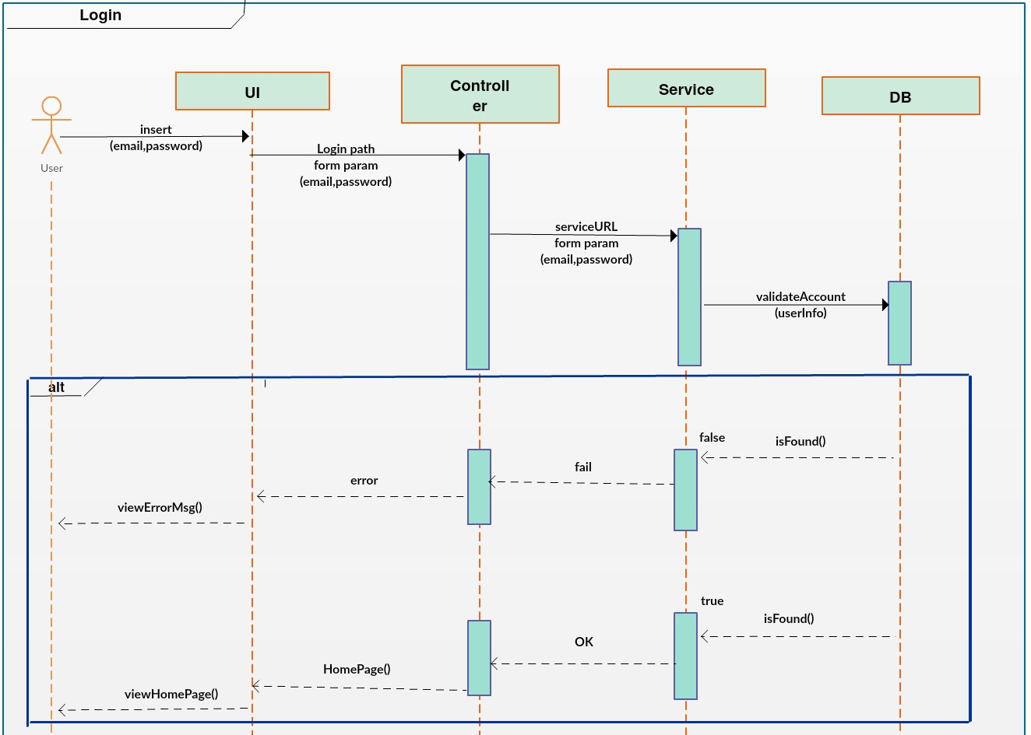

Figure 11 - Sequence Diagram - Login User

**AddOrdinaryNote**

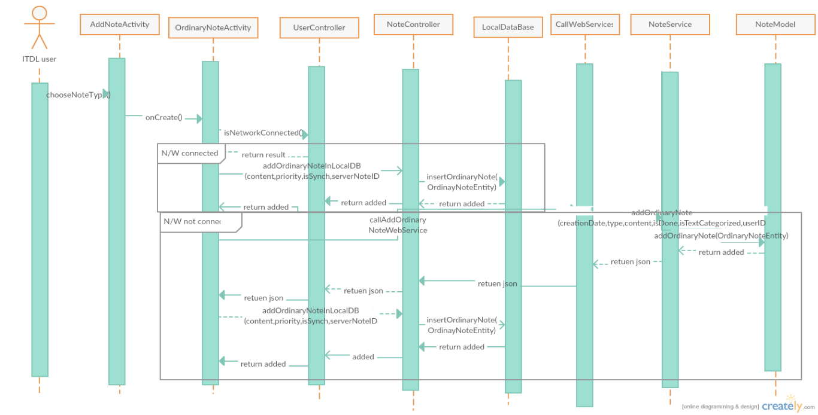

Figure 12 - Sequence Diagram – AddOrdinaryNote

**AddShoppingNote**

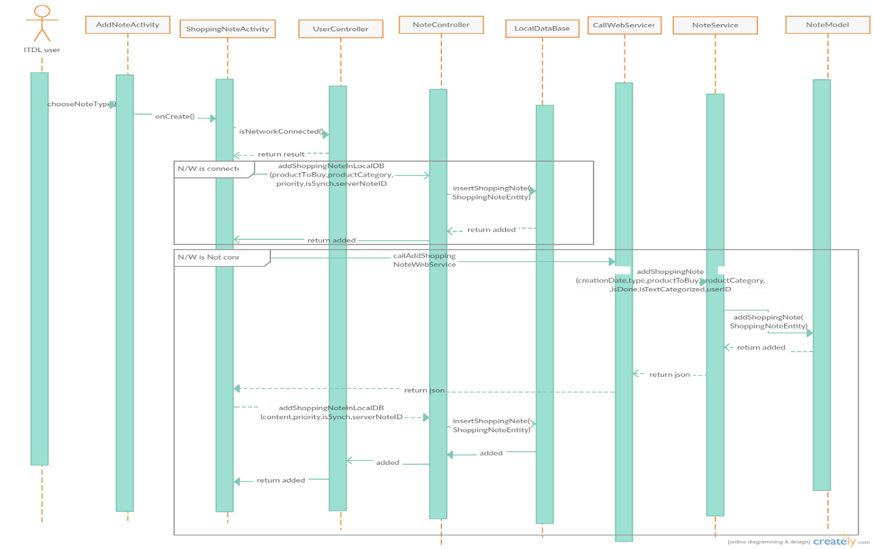

Figure 13 - Sequence Diagram – AddShoppingNote

**AddMeetingNote**

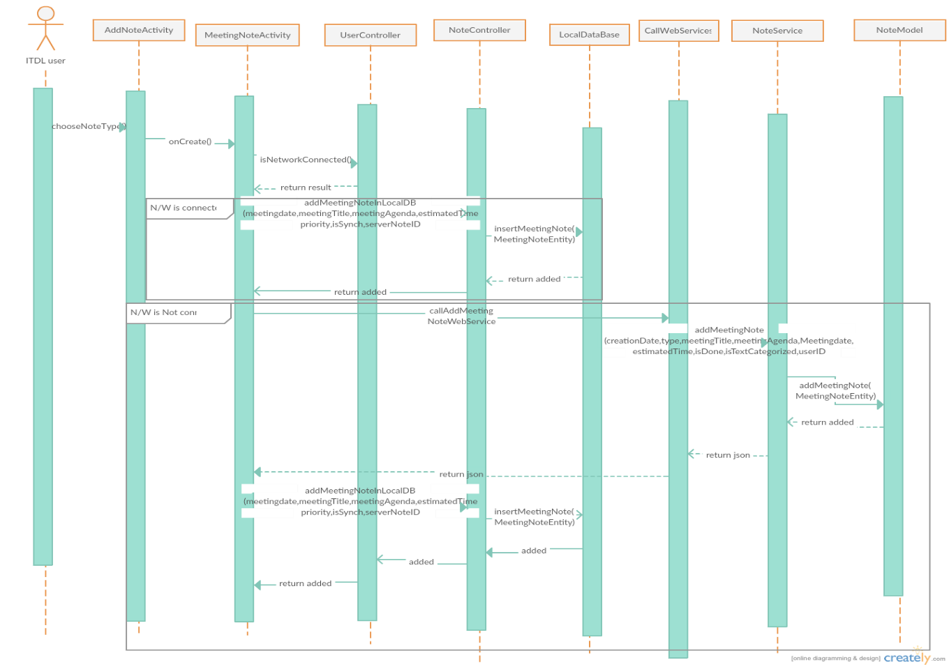

Figure 14 - Sequence Diagram - AddMeetingNote

**AddDeadlineNote**

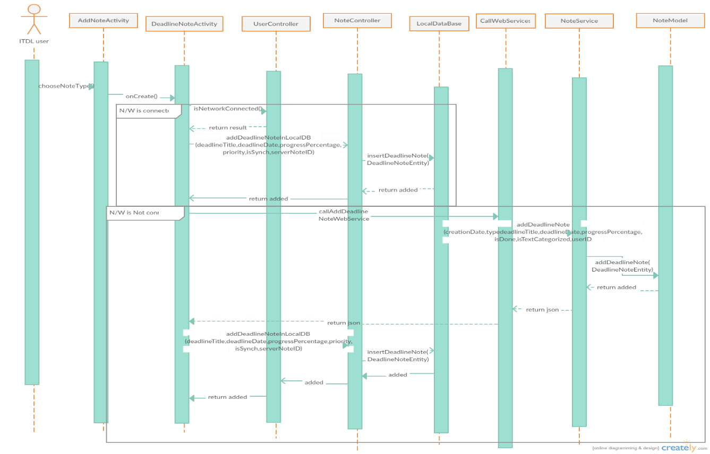

Figure 15 - Sequence Diagram - AddDeadlineNote

**UpdateNote**

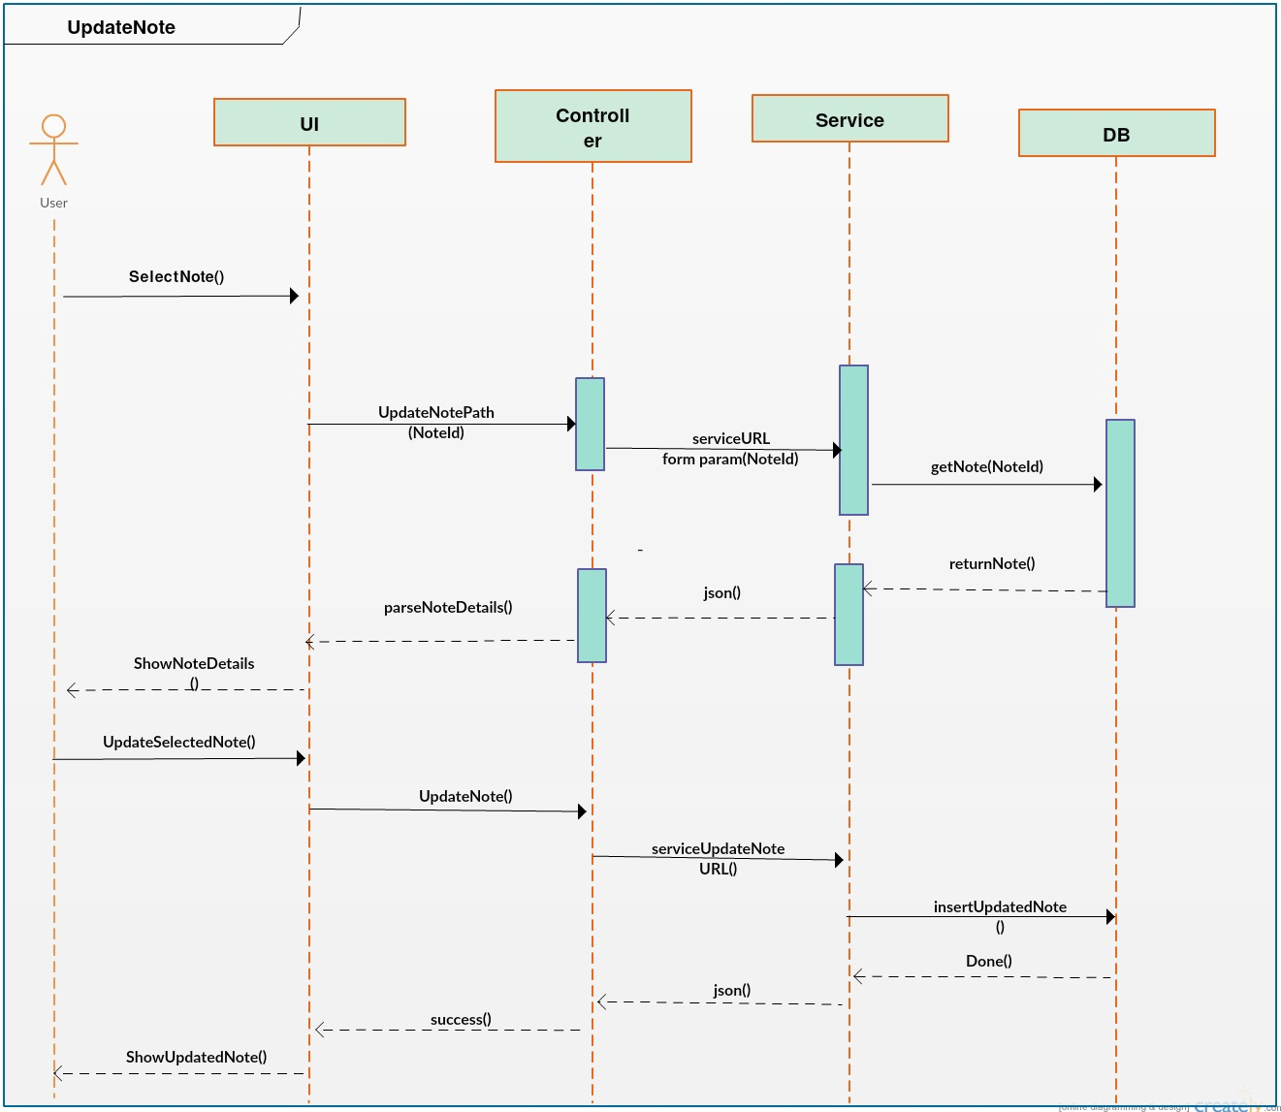

Figure 16 - Sequence Diagram - UpdateNote

**DeleteNote**

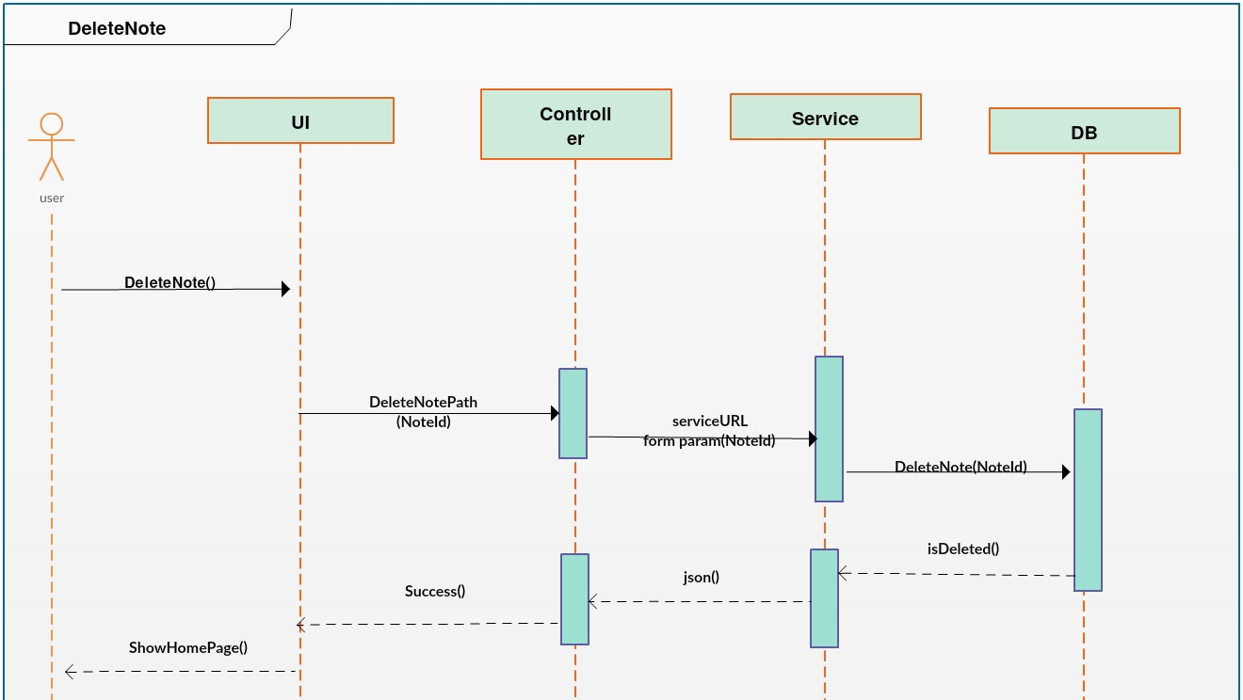

Figure 17 - Sequence Diagram - DeleteNote

**Show current and history notes**

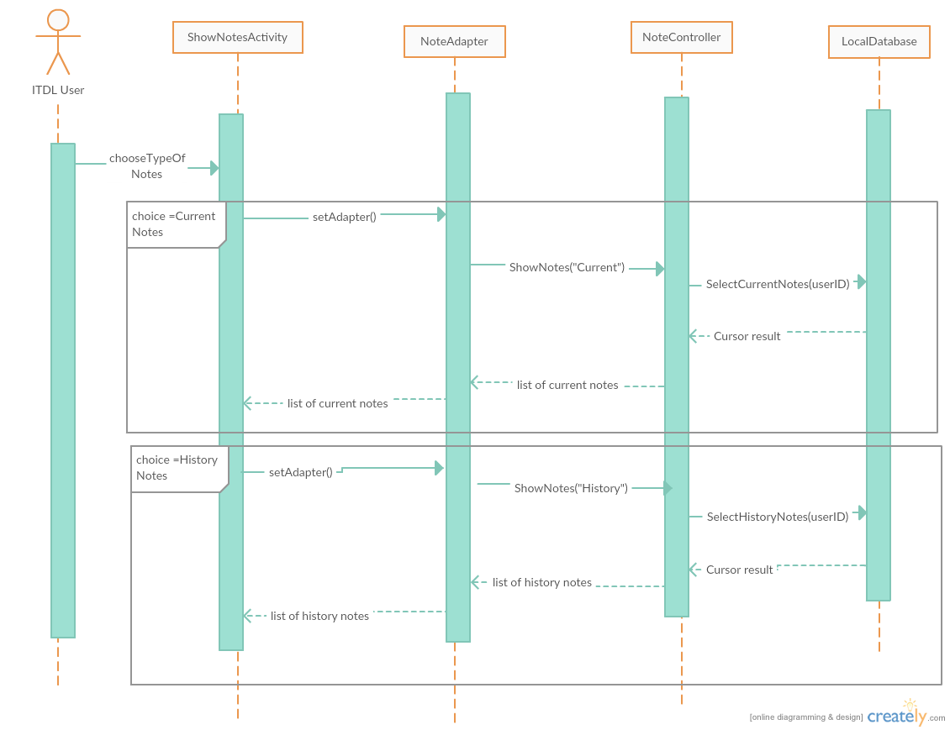

Figure 18 – Sequence Diagram – Show current and history notes

**Update preferences front end** 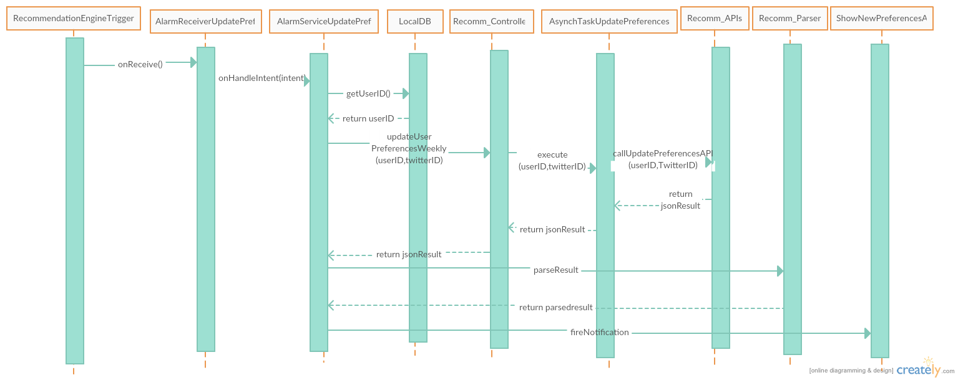

Figure 19 – Sequence Diagram – UpdatePrefFrontEnd

**Update preferences backend**

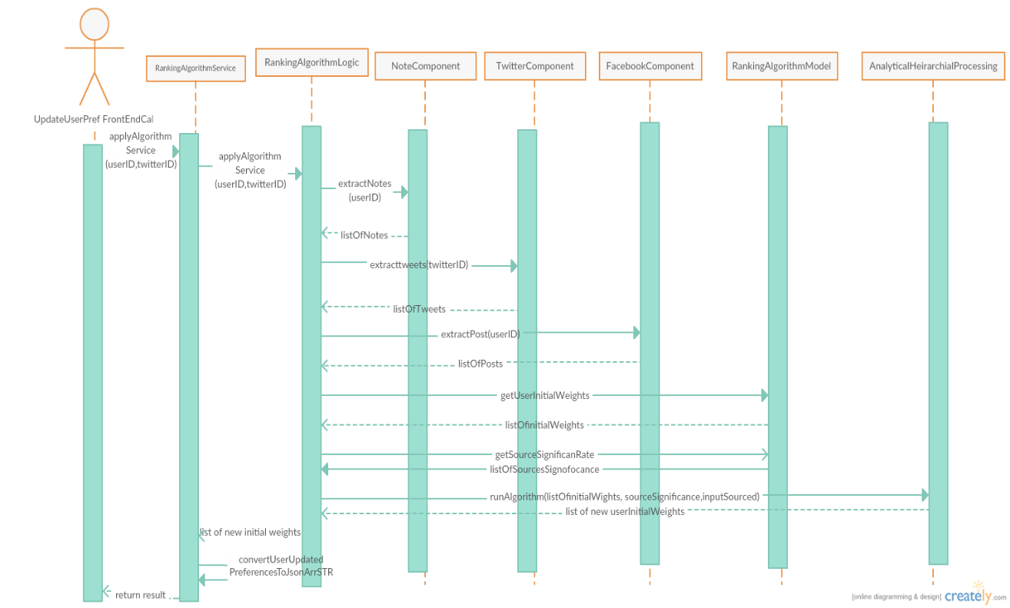

Figure 20 – Sequence Diagram – Update preferences backend

**getNeareastStores backend and frontend**

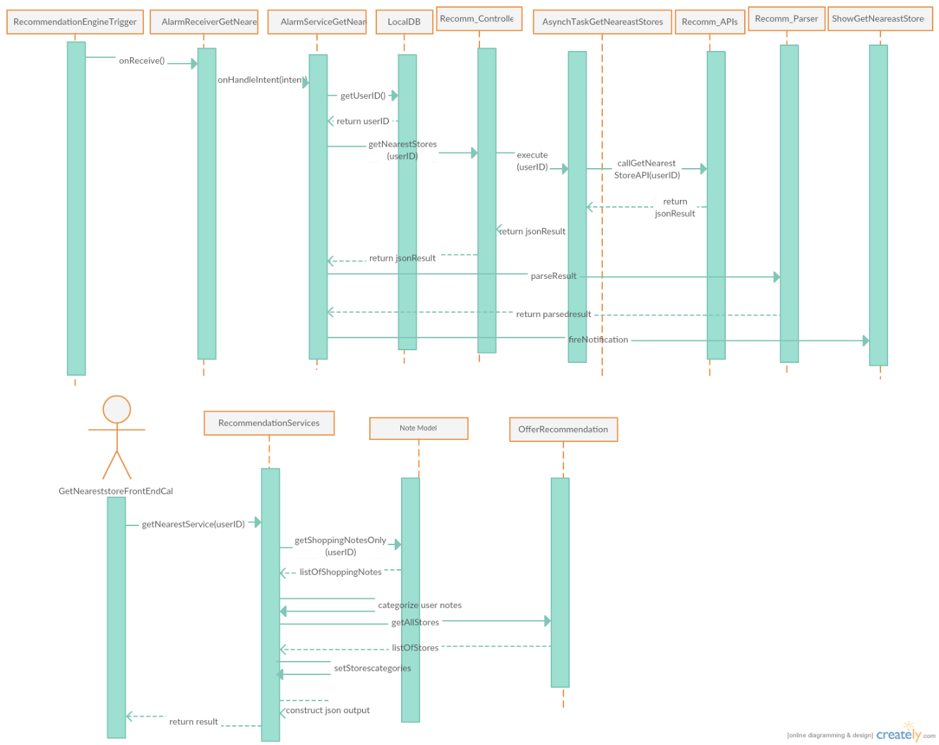

Figure 21 – Sequence Diagram – getNeareastStores

**getOffers backend and frontend**

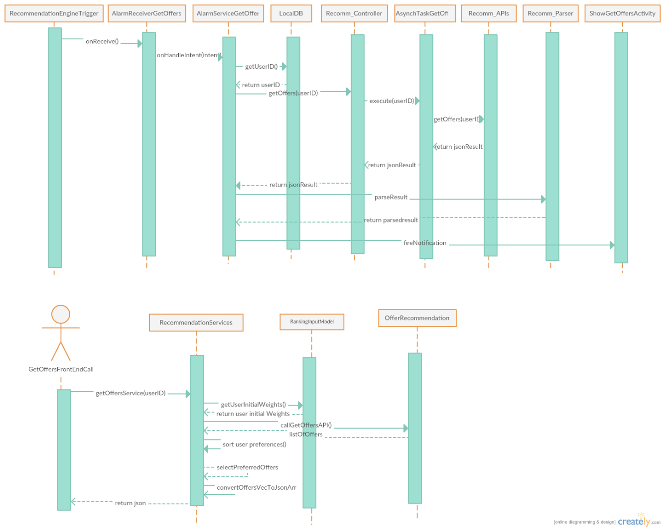

Figure 22 – Sequence Diagram – getOffers

**Web Part**

**SignupStore**

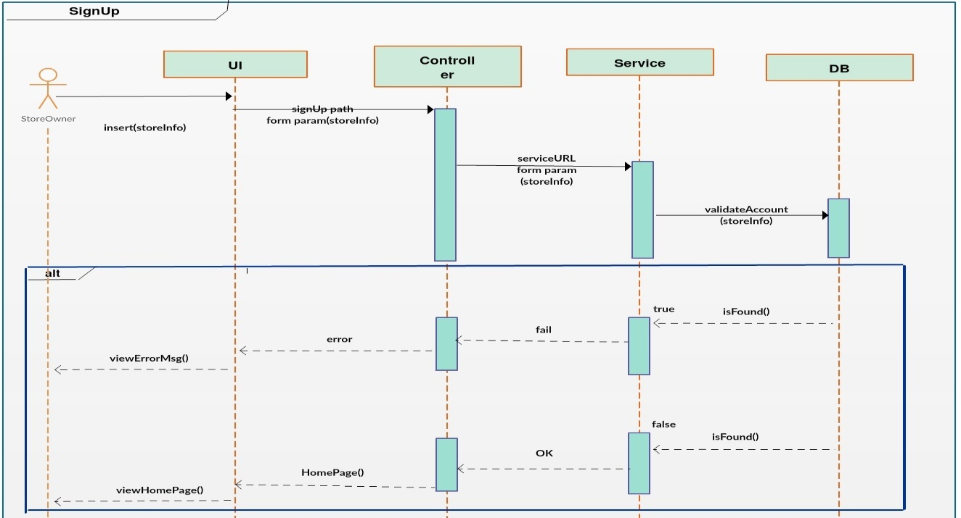

Figure 23 - Sequence Diagram - SignupStore

**LoginStore**

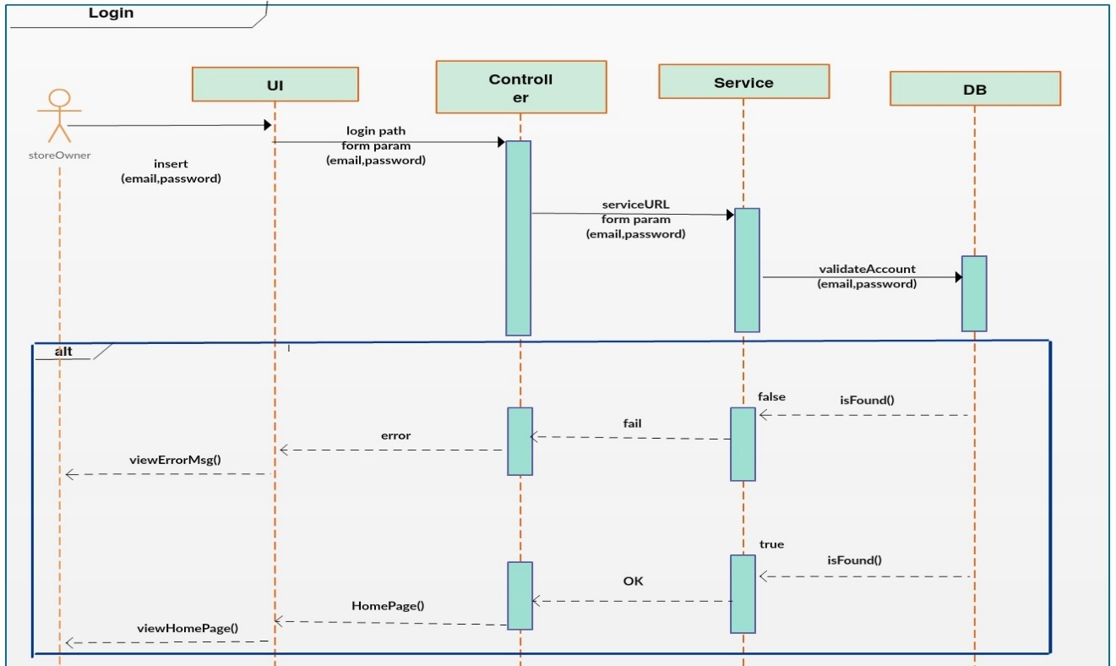

Figure 24 - Sequence Diagram - LoginStore

**AddOffer**

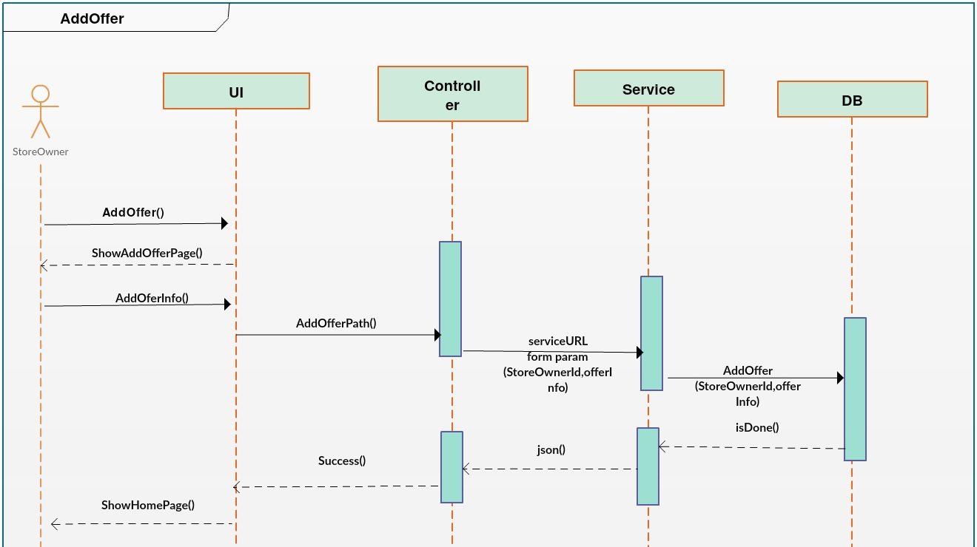

Figure 25 - Sequence Diagram - AddOffer

**UpdateOffer**

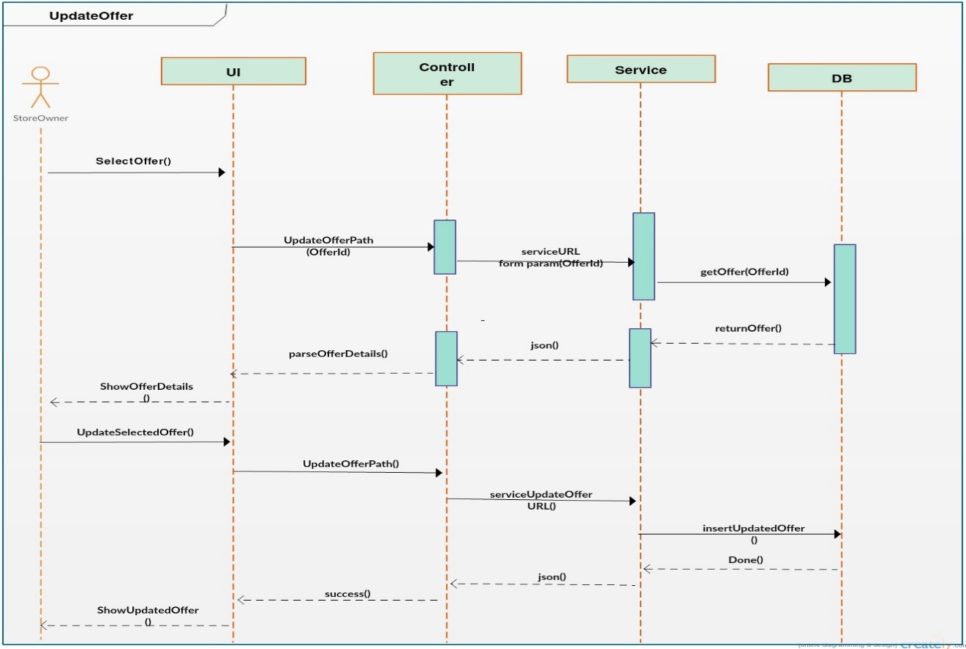

Figure 26 - Sequence Diagram - UpdateOffer

**DeleteOffer**

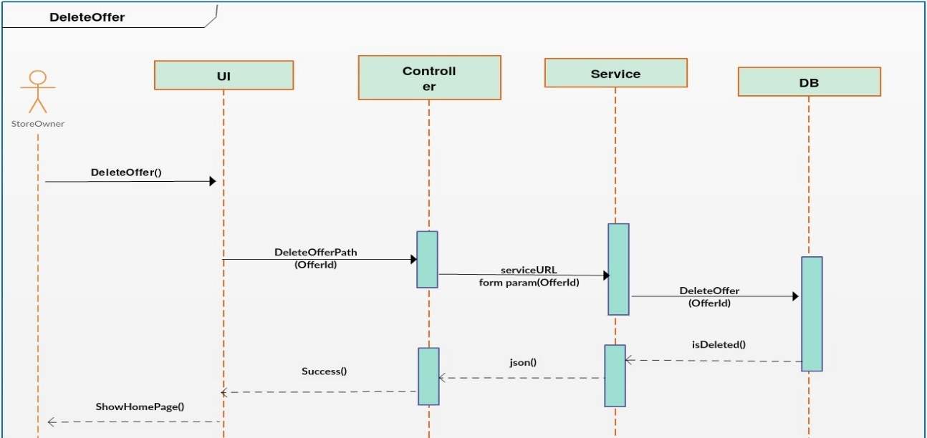

Figure 27 - Sequence Diagram – DeleteOffer

**UpdateStoreProfile**

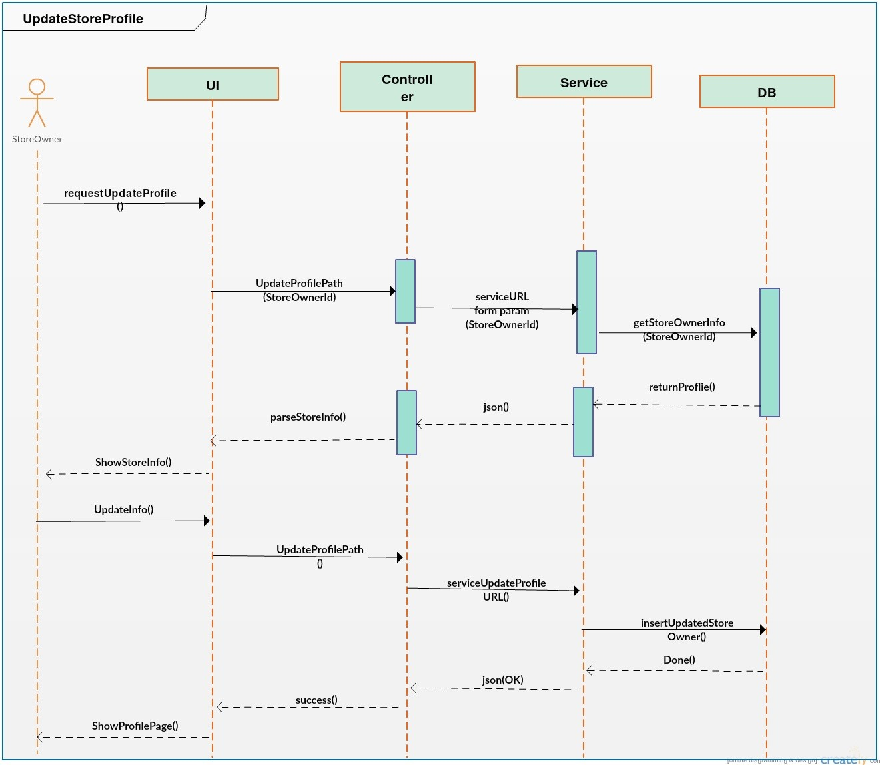

Figure 28 - Sequence Diagram - UpdateStoreProfile

## **System test cases.**

**Web Part**

Table 25 - Signup Store Method Inputs

|  |  |
| --- | --- |
| Input | Partitions |
| Email | E1: Email Exist in DB  E2: Email Not Exist in DB  E3: Email Not Given |
| Password | E4: Password size < 6  E5: Password Not Given  E6: Password size >= 6 |
| Name | E7: Name Not Given  E8: Name >= 6  E9: Name size < 6 |
| Coordinates | E10: Geolocation Permission Denied  E11: No Answer to Geolocation for long time  E12: No Internet Connection  E13: Geolocation not supported by the browser  E14: Geolocation Permission Allowed |

Table 26 - Signup Store Method Test Cases

|  |  |  |  |
| --- | --- | --- | --- |
| # | Input | Expected Output | Covered |
| 1 | Email: [Yasmeen.kloub@gmail.com](mailto:Yasmeen.kloub@gmail.com)  Password: 20120456  Name: Yasmin  Coordinates: 30.0012354, 31.1232455 | Registration Completed | E2, E6, E8, E14 |
| 2 | Email: [Yasmeen.kloub@gmail.com](mailto:Yasmeen.kloub@gmail.com)  Password: 123456  Name: Yasmin  Coordinates: 30.0012354, 31.1232455 | ERROR: Email Already Exist | E1, E6, E8, E14 |
| 3 | Email:  Password: 1234567  Name: Yasmin  Coordinates: 30.0012354, 31.1232455 | ERROR: Email Text Field Must be given | E3, E6, E8, E14 |
| 4 | Email: [Yasmeen.kloub@yahoo.com](mailto:Yasmeen.kloub@yahoo.com)  Password: 12345  Name: yasmin  Coordinates: 30.0012354, 31.1232455 | ERROR: Password Must be at least 6 characters | E2, E4, E8, E14 |
| 5 | Email: [Yasmin.kloub@gmail.com](mailto:Yasmin.kloub@gmail.com)  Password:  Name: Yasmin  Coordinates: 30.0012354, 31.1232455 | ERROR: Password Text Field Must be given | E2, E5, E8, E14 |
| 6 | Email: [yasmin.kloub@yahoo.com](mailto:yasmin.kloub@yahoo.com)  Password: 1234567  Name: yasso  Coordinates: 30.0012354, 31.1232455 | ERROR: User Name Must be at least 6 characters | E2, E6, E9, E14 |
| 7 | Email: [yasso.kloub@gmail.com](mailto:yasso.kloub@gmail.com)  Password: 1234567  Name:  Coordinates: 30.0012354, 31.1232455 | ERROR: User Name Text Field Must be given | E2, E6, E7, E14 |
| 8 | Email: [yasso.kloub@yahoo.com](mailto:yasso.kloub@yahoo.com)  Password: 1234567  Name: Yasmin  Coordinates: Deny | ERROR: User denied the request for Geolocation. | E2, E6, E8, E10 |
| 9 | Email: [Yasmeen.latif@gmail.com](mailto:Yasmeen.latif@gmail.com)  Password: 1234567  Name: Yasmin  Coordinates: No Answer to the Request | ERROR: The request to get user location timed out. | E2, E6, E8, E11 |
| 10 | Email: [Yasmeen.latif@yahoo.com](mailto:Yasmeen.latif@yahoo.com)  Password: 1234567  Name: Yasmin  Coordinates: No Internet Connection | ERROR: Location information is unavailable. | E2, E6, E8, E12 |
| 11 | Email: [Yasmin.latif@gmail.com](mailto:Yasmin.latif@gmail.com)  Password: 1234567  Name: Yasmin  Coordinates: IE9 | ERROR: Geolocation is not supported by this browser. | E2, E6, E8, E13 |

Table 27 - Login Store Method Inputs

|  |  |
| --- | --- |
| Input | Partitions |
| Email | E1: Email Exist in DB  E2: Email Not Exist in DB  E3: Email Not Given |
| Password | E4: Password Not Right  E5: Password Not Given  E6: Password Right |

Table 28 - Login Store Method Test Cases

|  |  |  |  |
| --- | --- | --- | --- |
| # | Input | Expected Output | Covered |
| 2 | Email: [Yasmeen.kloub@gmail.com](mailto:Yasmeen.kloub@gmail.com)  Password: 123456 | Home Page | E1, E6 |
| 1 | Email: [Yasmin.latif@yahoo.com](mailto:Yasmin.latif@yahoo.com)  Password: 20120456 | ERROR: Email Doesn’t Exist | E2, E6 |
| 3 | Email:  Password: 1234567 | ERROR: Email Text Field Must be given | E3, E6 |
| 4 | Email: [Yasmeen.kloub@yahoo.com](mailto:Yasmeen.kloub@yahoo.com)  Password: 12345 | ERROR: You Have Entered a Wrong Password | E2, E4 |
| 5 | Email: [Yasmin.kloub@gmail.com](mailto:Yasmin.kloub@gmail.com)  Password: | ERROR: Password Text Field Must be given | E2, E5 |

Table 29 – Add/Update Offer Method Inputs

|  |  |
| --- | --- |
| Input | Partitions |
| Start Date | E1: End Date > Start Date => Current Date  E2: Start Date < Current Date  E3: Start Date Not Given |
| End Date | E4: End Date > Current Date  E5: End Date < Start Date  E6: End Date < Current Date  E7: End Date Not Given |
| Category | E8: Category is Selected  E9: Category Not Selected |
| Content | E10: Content is Selected, E11: Content Not Selected |

Table 30 – Add/Update Offer Method Test Cases

|  |  |  |  |
| --- | --- | --- | --- |
| # | Input Assuming Current Date = (2/6/2016) | Expected Output | Covered |
| 1 | Start Date: 3/6/2016  End Date: 6/6/1016  Category: Food and Drinks  Content: Order 2 Pizza and get one Free | Offer Added Successfully | E1, E4, E8, E10 |
| 2 | Start Date: 1/6/2016  End Date: 6/6/1016  Category: Food and Drinks  Content: Order 2 Pizza and get one Free | ERROR: Start Date Must Be After the Current Date | E2, E4, E8, E10 |
| 3 | Start Date:  End Date: 6/6/1016  Category: Food and Drinks  Content: Order 2 Pizza and get one Free | ERROR: Start Date Must Be Given | E3, E4, E8, E10 |
| 4 | Start Date: 4/6/2016  End Date: 3/6/1016  Category: Food and Drinks  Content: Order 2 Pizza and get one Free | ERROR: End Date Must Be After the Start Date | E1, E5, E8, E10 |
| 5 | Start Date: 4/6/2016  End Date: 1/6/1016  Category: Food and Drinks  Content: Order 2 Pizza and get one Free | ERROR: End Date Must Be After the Current Date and the Start Date | E1, E5, E6, E8, E10 |
| 6 | Start Date: 3/6/2016, End Date:  Category: Food and Drinks  Content: Order 2 Pizza and get one Free | ERROR: End Date Must Be Given | E1, E7, E8, E10 |
| 7 | Start Date: 3/6/2016  End Date: 6/6/1016, Category:  Content: Order 2 Pizza and get one Free | ERROR: Category Must Be Selected | E1, E4, E9, E10 |
| 8 | Start Date: 3/6/2016  End Date: 6/6/1016  Category: Food and Drinks, Content: | ERROR: Content Must Be Given | E1, E4, E8, E11 |

**Android Part**

Table 31 - Signup User Method Inputs

|  |  |
| --- | --- |
| Input | Partitions |
| User object | E1: User object is null.  E2: User object is not null. |
| User Name | E3:UserName is null  E4:USerName is not null |
| User Password | E5: User Password is null  E6: User Password is not null |
| User Email | E7: Email valid  E8:Email not valid  E9:Email is null |
| User Gender | E10: gender is null  E11:gender is not null |
| User birth date | E12: birth date<Current date  E13 : birth date >=Current date |
| Twitter Username | E14: Username valid  E15:Email not valid |

Table 32 - Signup User Method Test Cases

|  |  |  |  |
| --- | --- | --- | --- |
| # | Input | Expected Output | Covered |
| 1 | User=null | NullPointerException (Assumed) | E1 |
| 2 | User name =""  Userpassword="1234567"  Useremail=ahmed@yahoo.com  Usergender="male"  userbirthdate="2/1/1990"  TwitterUsername="@ahmed" | Failed to sign up | E2,E3,E6,E7,E11  E12,E14 |
| 3 | User name ="ahmed"  Userpassword=""  Useremail=ahmed@yahoo.com  Usergender="male"  userbirthdate="2/1/1990"  TwitterUsername="@ahmed" | Failed to sign up | E2,E3,E5,E7,E11  E12,E14 |
| 4 | User name ="ahmed",  Userpassword="1234567"  Useremail=a@yahoo.com  Usergender="male"  userbirthdate="2/1/1990"  TwitterUsername="@ahmed" | Failed to sign up | E2,E3,E6,E8,E11  E12,E14 |
| 5 | User name ="ahmed",  Userpassword="1234567",  Useremail= "",  Usergender="male",userbirthdate="2/1/1990"  TwitterUsername="@ahmed" | Failed to sign up | E2,E3,E6,E9,E11  E12,E14 |
| 6 | User name ="mona",  Userpassword="1234567"  Useremail= mona12@yahoo.com  Usergender="", userbirthdate="2/1/1990"  TwitterUsername="@mona" | Failed to sign up | E2,E3,E6,E9,E10  E12,E14 |
| 7 | User name ="mona",  Userpassword="1234567",  Useremail=mona12@yahoo.com  Usergender="female ", userbirthdate="2/3/2016"  TwitterUsername="@mona" | Failed to sign up | E2,E3,E6,E9,E10  E13,E14 |
| 8 | User name ="mona",  Userpassword="1234567",  Useremail=mona12@yahoo.com,  Usergender="female", userbirthdate="2/3/1990"  TwitterUsername="@mona" | Register Successes | E2,E3,E6,E9,E10  E12,E14 |
|  |  |  |  |

Table 33 - Login User Method Inputs

|  |  |
| --- | --- |
| Input | Partitions |
| email | E1: email is valid.  E2: email is not valid. |
| password | E3: password is correct.  E4: password is not correct. |

Table 34 - Login User Method Test Cases

|  |  |  |  |
| --- | --- | --- | --- |
| # | Input | Expected Output | Covered |
| 1 | Email="gp@yahoo.com", password="123456"  (Assumed this mail exist in DB) | logged in Successfully | E1,E3 |
| 2 | Email="gp12@yahoo.com", password="123456"  (Assumed this mail it doesn’t exist in DB) | Failed to log in | E2 |
| 3 | Email="gp@yahoo.com", password="12345689"  (Assumed this mail exist in DB but this password isn’t correct) | Failed to log in | E4,E3 |

Table 35 - Add/Update Ordinary Note Method Inputs

|  |  |
| --- | --- |
| Input | Partitions |
| OrdinaryNote object | E1: OrdinaryNote object is null.  E2: OrdinaryNote object is not null. |

Table 36 - Add/Update Ordinary Note Method Test Cases

|  |  |  |  |
| --- | --- | --- | --- |
| # | Input | Expected Output | Covered |
| 1 | Note=null | NullPointerException (Assumed) | E1 |
| 2 | Note="I want to play Football" | True | E2 |

Table - Add Meeting Note Method Inputs

|  |  |
| --- | --- |
| Input | Partitions |
| title | E1: title is null.  E2: title is not null. |
| content | E3: content is null.  E4: content is not null. |
| Date | E5: Date < Current date.  E6: Date >= Current date. |

Table 38 - Add/Update Meeting Note Method Test Cases

|  |  |  |  |
| --- | --- | --- | --- |
| # | Input | Expected Output | Covered |
| 1 | Title=null, content="GP Meeting",Date="7/2/2016"  (Assumed Current Date="2/2/2016") | NullPointerException  (Assumed) | E1,E4,E6 |
| 2 | Title=GP, content="GP Meeting",Date="7/2/2016"  (Assumed Current Date="2/2/2016") | True | E2,E4,E6 |
| 3 | Title=GP, content=null, Date="7/2/2016"  (Assumed Current Date="2/2/2016") | NullPointerException  (Assumed) | E3,E2,E6 |
| 4 | Title=GP, content="GP Meeting",Date="7/2/2016"  (Assumed Current Date="2/2/2016") | True | E4,E2,E6 |
| 5 | Title=GP, content="GP Meeting",Date=="20/1/2016"  (Assumed Current Date="2/2/2016") | InvalidParameterException  (Assumed) | E5,E2,E4 |
| 6 | Title=GP, content="GP Meeting",Date="7/2/2016"  (Assumed Current Date="2/2/2016") | True | E6,E2,E4 |

Table 39 - Add/Update Deadline Note Method Inputs

|  |  |
| --- | --- |
| Input | Partitions |
| DeadlineNote object | E1: DeadlineNote object is null.  E2: DeadlineNote object is not null. |
| Deadline Date | E3: Deadline Date>Current Date  E4:Deadline Date <=Current Date |
| progress | E5: progress<0  E6:progress >100  E7:0<=Progress <=100 |
| title | E8:title is null  E9:title is not null |
| content | E10:content is null  E11:content is not null |

Table 40 - Add/Update Deadline Note Method Test Cases

|  |  |  |  |
| --- | --- | --- | --- |
| # | Input | Expected Output | Covered |
| 1 | Content="Assignment is about chapter 1"  DeadlineDate=4/2/2016  Current Date=6/2/2016  Progress =0,title="Assignment  IA" | Failed to add/Update Note | E2,E4,E7,E9,E11 |
| 2 | Content="Assignment is about chapter 1"  DeadlineDate=9/2/2016  Current Date=6/2/2016  Progress =0,title="Assignment  IA" | Note Added/Updated Successfully | E2,E3,E7,E9,E11 |
| 3 | Content="Assignment is about chapter 1"  DeadlineDate=9/2/2016  Current Date=6/2/2016  Progress =-1,  title="Assignment  IA" | Failed to add/Update Note | E2,E4,E5,E9,E11 |
| 4 | Content="Assignment is about chapter 1"  DeadlineDate=9/2/2016  Current Date=6/2/2016  Progress =120,  title="Assignment  IA" | Failed to add/Update Note | E2,E4,E6,E9,E11 |
| 5 | Content=""  DeadlineDate=9/2/2016  Current Date=6/2/2016  Progress =50, title="Assignment  IA" | Failed to add/Update Note | E2,E4,E7,E9,E10 |
| 6 | Content="Assignment is about chapter 1"  DeadlineDate=9/2/2016  Current Date=6/2/2016  Progress =50, title="" | Failed to add/Update Note | E2,E4,E7,E8,E11 |

Table 41 - Add/Update Shopping Note Method Inputs

|  |  |
| --- | --- |
| Input | Partitions |
| ShoppingNote object | E1: ShoppingNote object is null.  E2: ShoppingNote object is not null. |
| Category | E3: Category null  E4:Category not null |
| content | E5:content is null  E6:content is not null |

Table 42 - Add/Update Shopping Note Method Test Cases

|  |  |  |  |
| --- | --- | --- | --- |
| # | Input | Expected Output | Covered |
| 1 | ShoppingNote() | NullPointerException (Assumed) | E1 |
| 2 | ShoppingNote  !=null,Content="milk"  Category =" " | Failed to add/Update note | E2,E3,E6 |
| 3 | ShoppingNote  !=null,Content=""  Category ="food" | Failed to add/Update Note | E2,E3,E5 |
| 4 | ShoppingNote  !=null,Content="cheese"  Category ="food" | Note added/Updated Successfully | E2,E4,E6 |

# **Chapter 4: Screen Shots**



## **ANDROID APP SCREEN SHOTS**

* + 1. **Sign up**

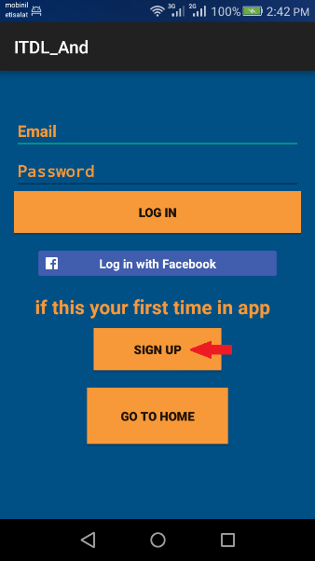 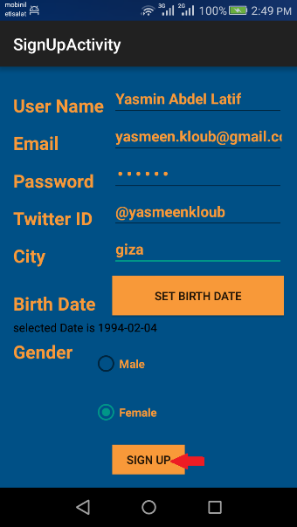 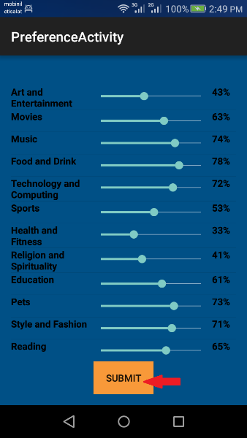 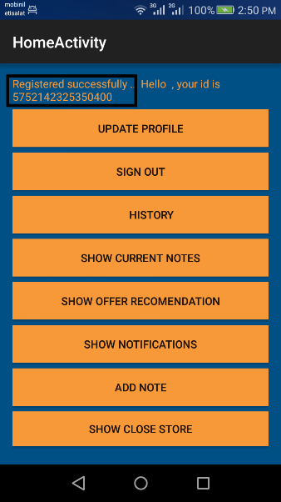

* + 1. **Log in**

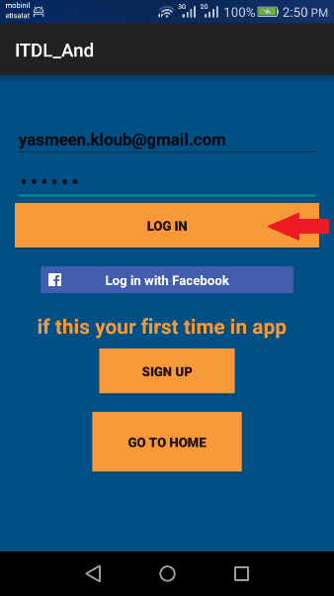 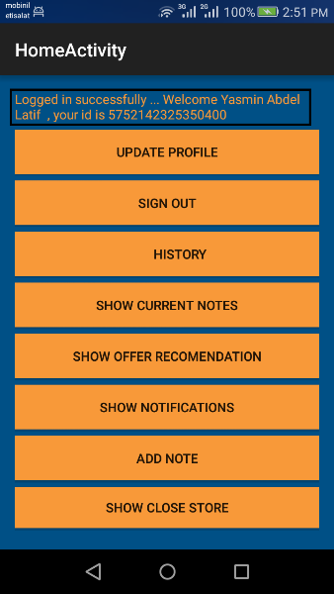

* + 1. **Add Meeting Note**

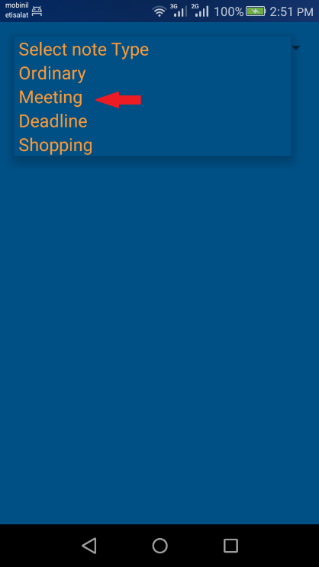 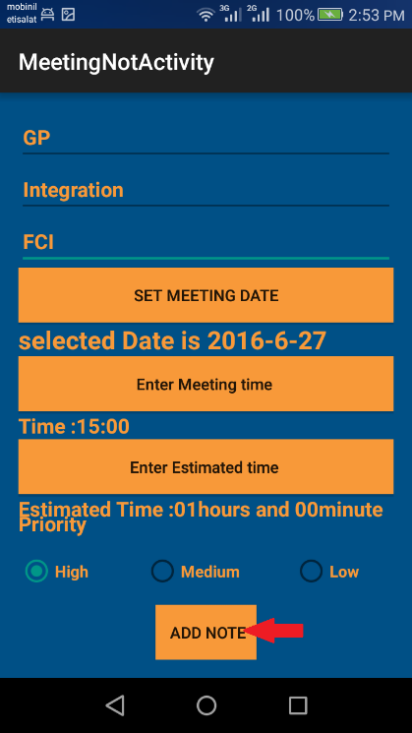 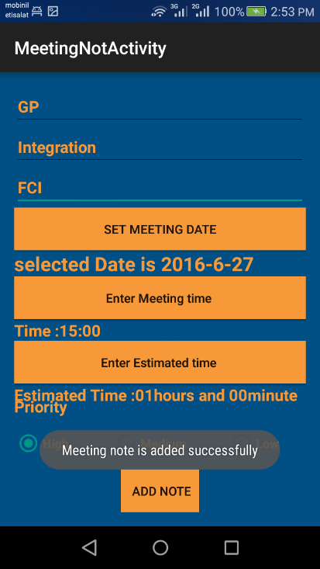

* + 1. **Add Deadline Note**

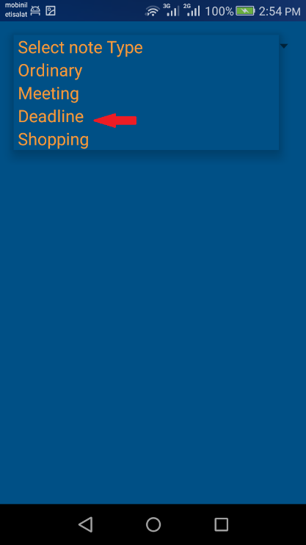 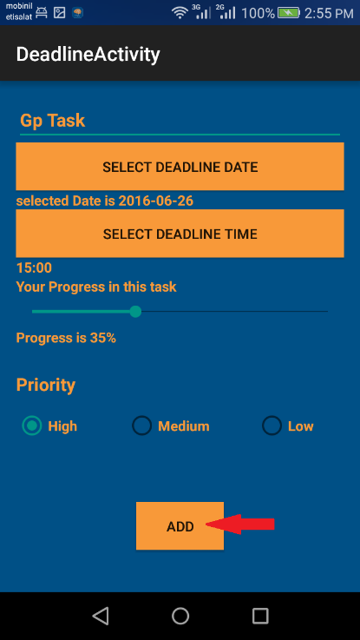 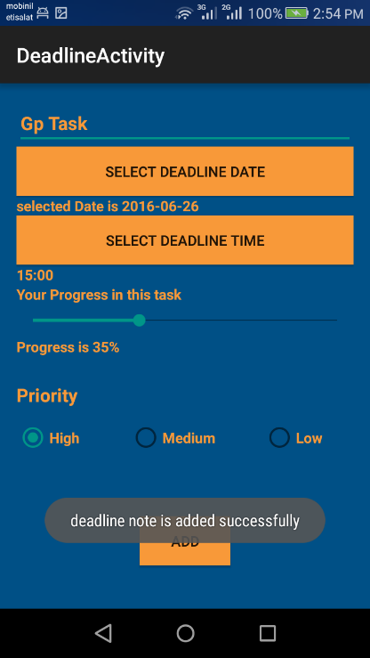

* + 1. **Add Ordinary Note**

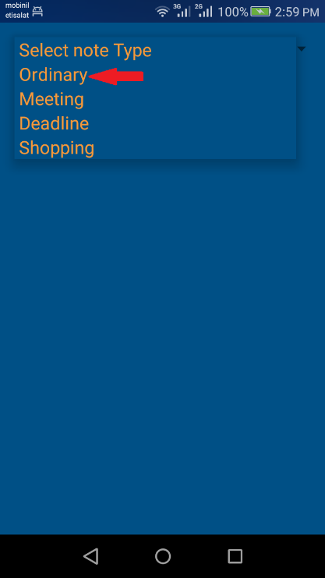 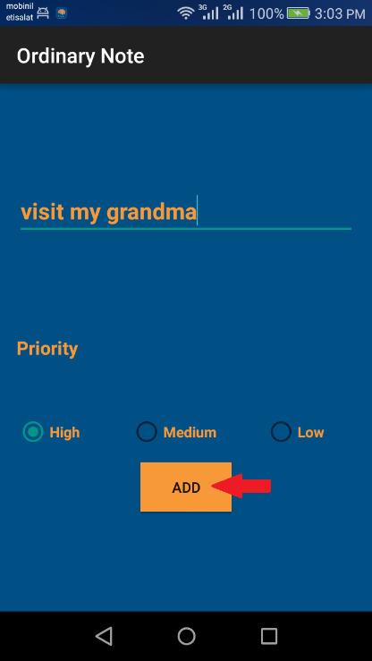 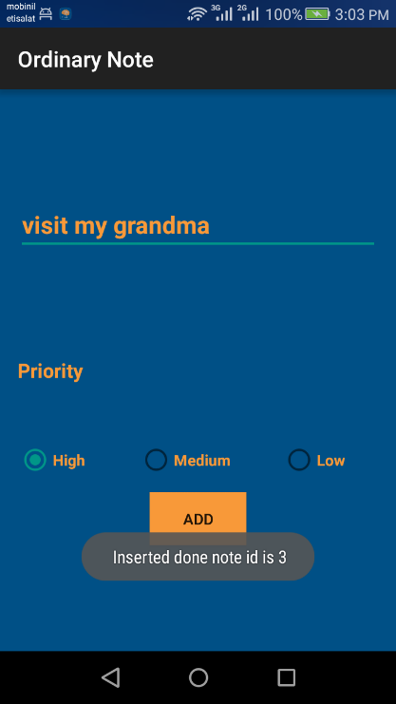

* + 1. **Add Shopping Note**

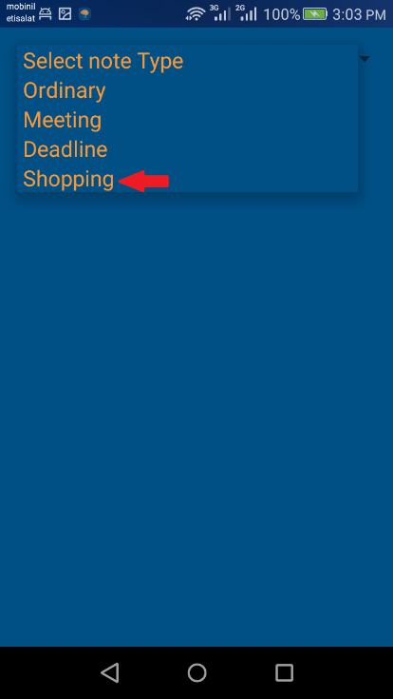 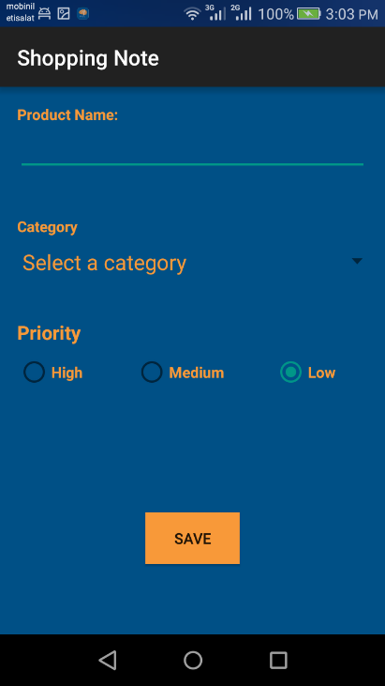 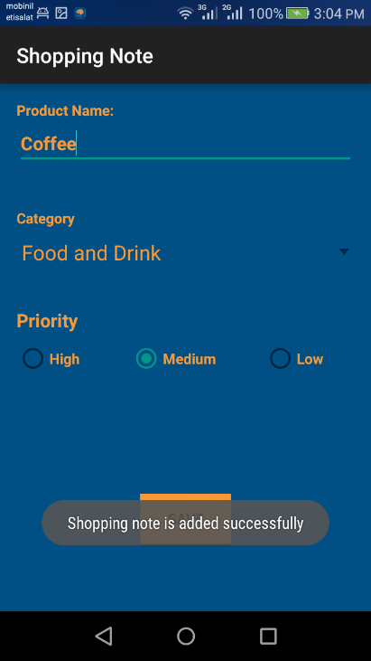

* + 1. **Get Meeting Alarm**

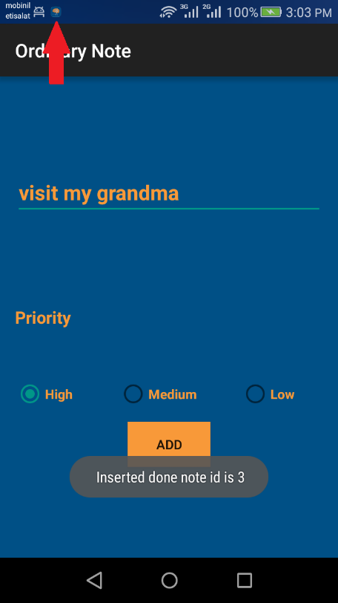 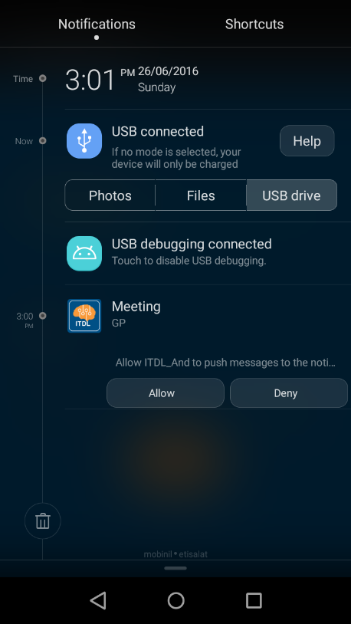 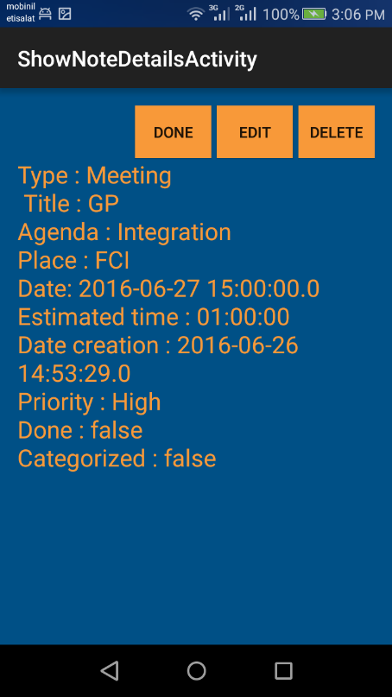

* + 1. **Get Deadline Alarm**

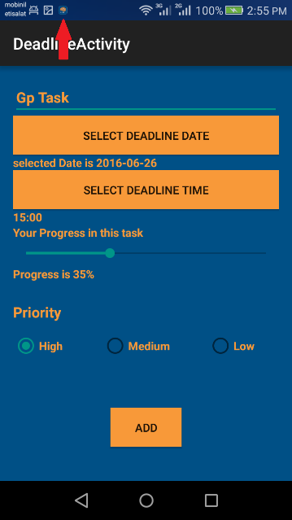 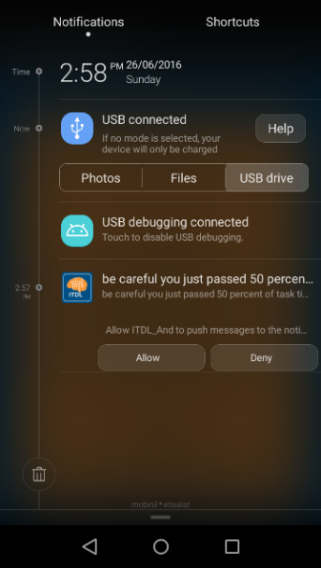 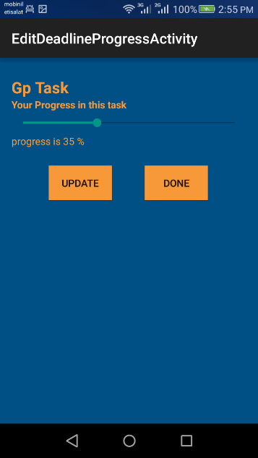 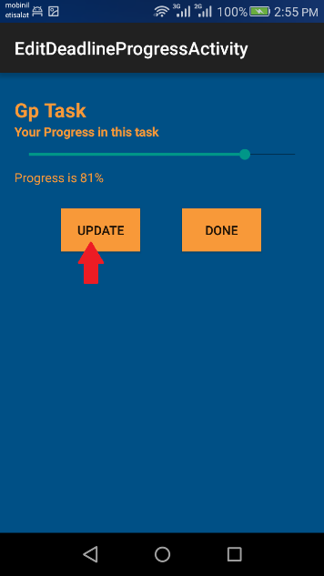

* + 1. **Get Nearest Store Notification**

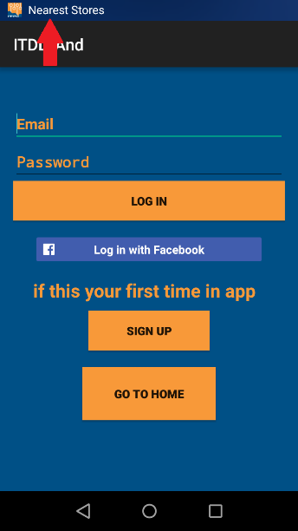 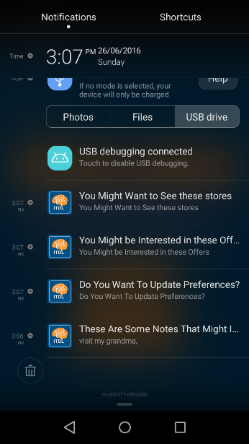 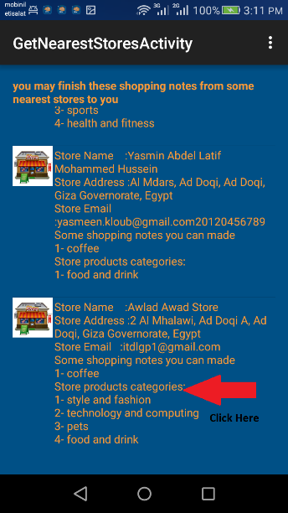 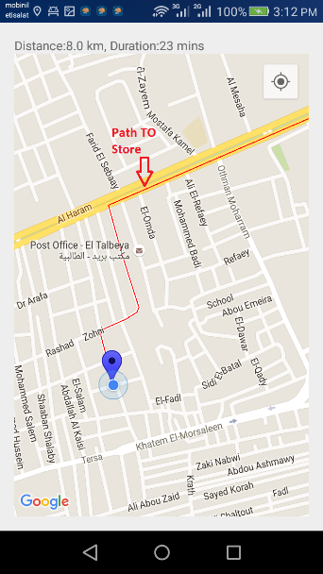

* + 1. **Get Nearest Offers Notification**

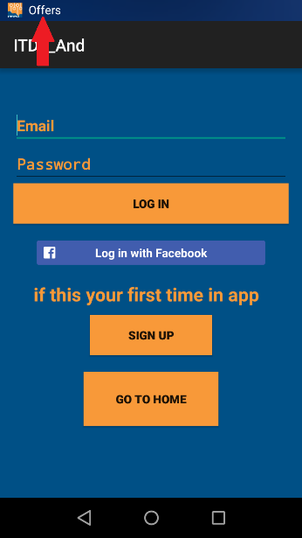 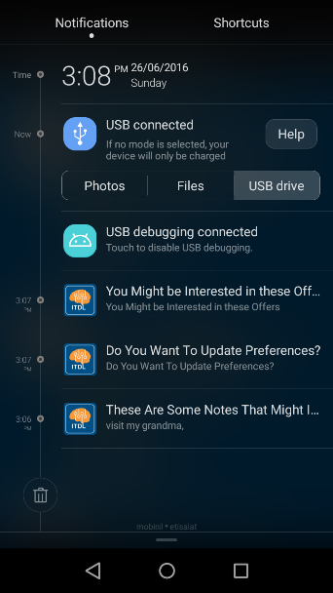 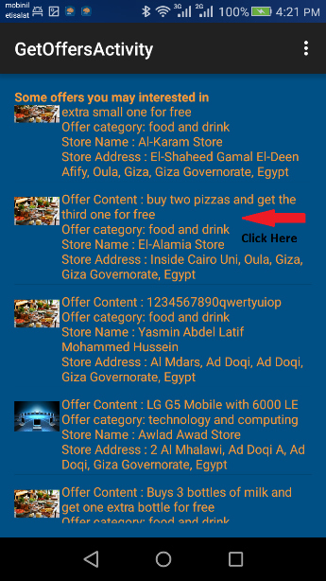 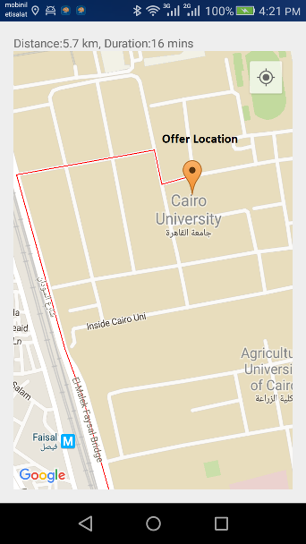

* + 1. **Get Update Preferences Notification**

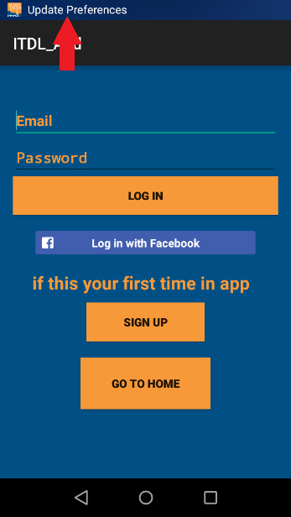 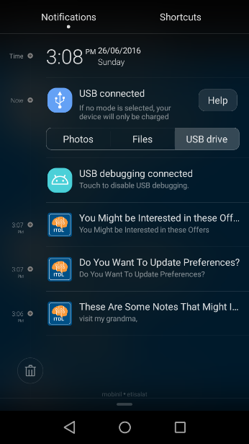 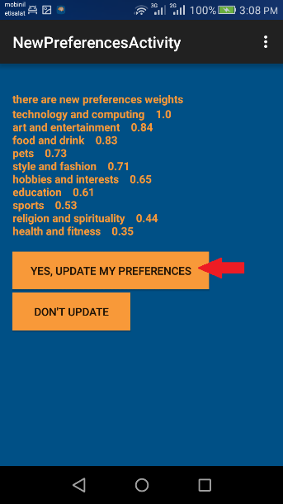 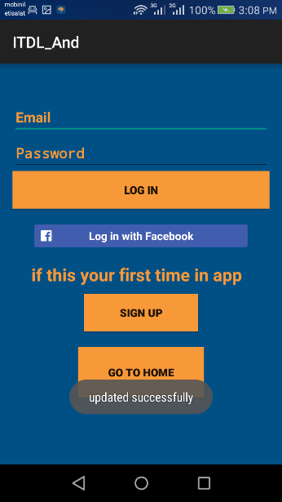

* + 1. **Get Suggested Actions Notification**

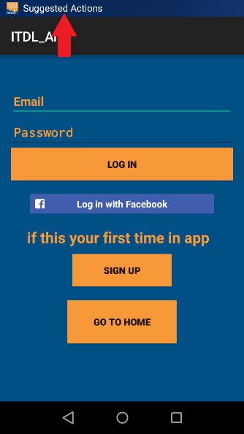 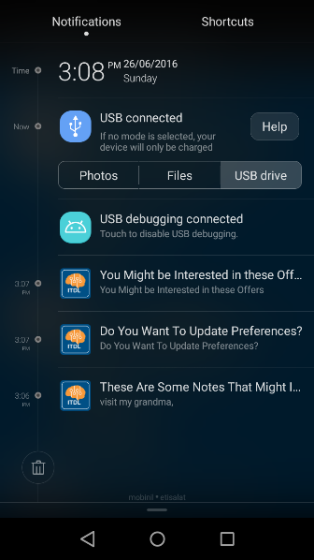 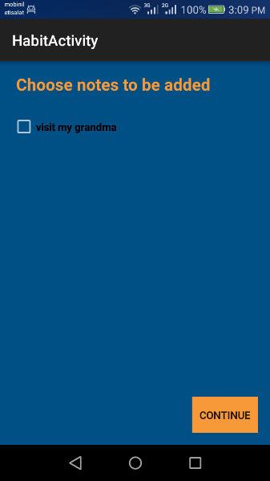

## **WEB SCEENS (ADD OFFER)**

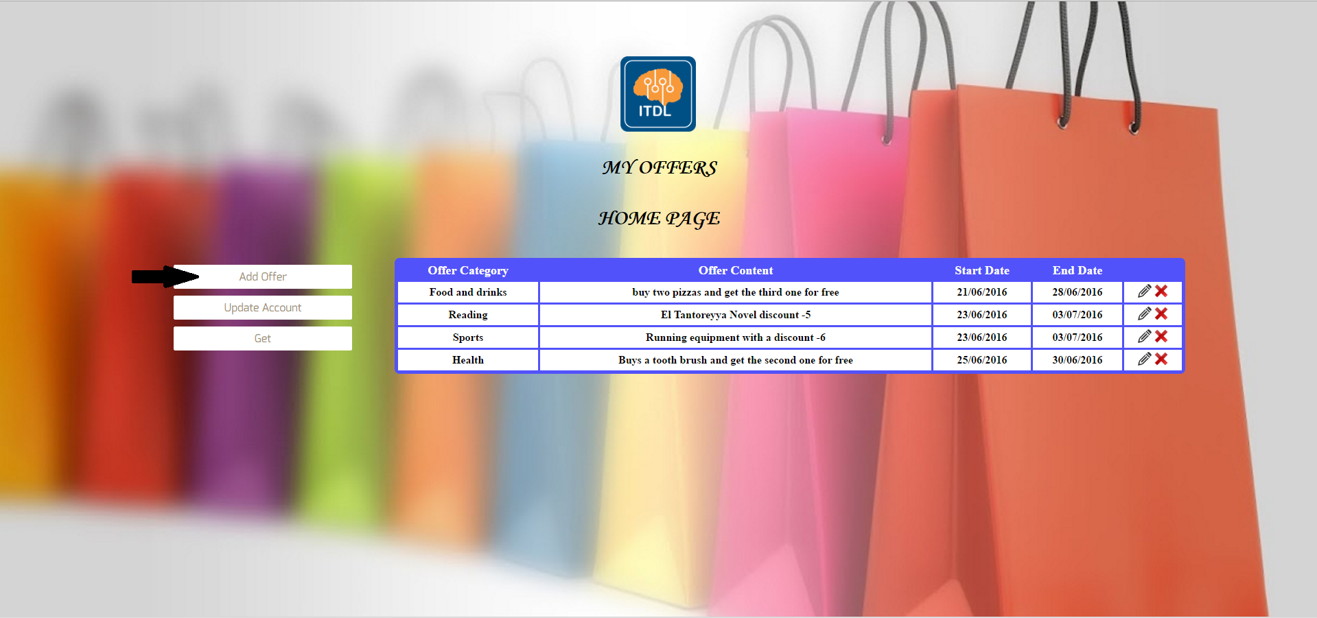

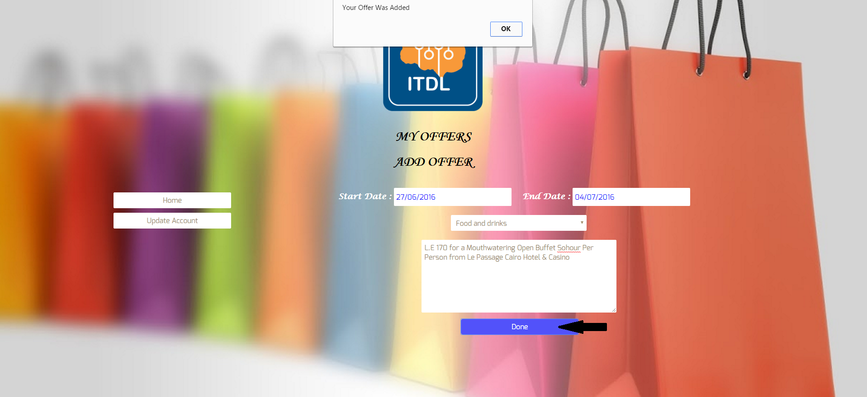

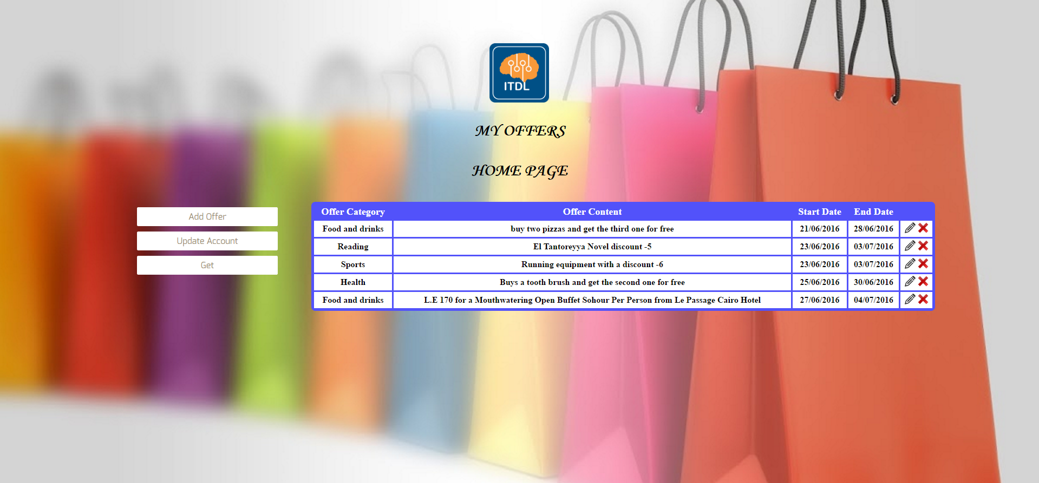

# **Chapter 5**

## **Conclusion**

To sum up our project, Intelligent to do list help user to organize his tasks in intelligent way. Trying to understand the user behavior by analyzing the text from input sources like user daily notes, tweets or Facebook.

Each note type is handled in different way

Deadline note: user is notified multiple times before the deadline and visualize the progress percentage to encourage him finish his work.

Meeting note: system notified the user before the meeting by 1 day and by the transport time

Shopping note: user can organize his products he wants to buy and the system recommend him some stores that he may handle some shopping notes

Ordinary note: user can write any notes that are not in the previous categories. System make use from these notes by detecting the user habits and suggest them some actions to do.

ITDL application always updates the user interests weekly and inform the user by these updates in order not to enforce these updates and according to his action system will update his initial weights or not.

## **Future work**

This application can be enhanced by adding some features and enhancing the recommendation engine.

* We can add sharing feature in the meeting and deadline notes. So user can make network of friends so we can use collaborative filtering recommendation algorithm. Lenskit tool provide implementation for these algorithms. This is an open source project which can be embedded in our application.
* Implementing web version of the application and synchronize data between the mobile and the web.
* Support Arabic language.

# **References**

<https://dev.twitter.com/>

<http://www.alchemyapi.com/>

<https://www.uclassify.com/>

<http://developer.android.com/index.html>

<http://www.tutorialspoint.com/android/android_tutorial.pdf>

<http://www.oodesign.com/>

<https://www.youtube.com/watch?v=s7wmiS2mSXY>

<http://lenskit.org/>

<https://en.wikipedia.org/wiki/Analytic_hierarchy_process>